

Faculty of Computing and Information Technology

Assignment 2020/2021

AACS1084 Programming Concepts & Design II

Programme : DCS1

Tutorial Group : 1

Tutor : Ms Goh Kim Nee

|  |  |
| --- | --- |
| **Student Name** | **Module handled** |
| Lee Seng Wai | Venue Information Module |
| Tan Eng Lip | Visitor Information Module |
| Thong So Xue | Sanitization Records Module |
| Wang Shu Wei | Visits and Exits Module |
| Wong Jun Wei | Administrative Staff Module |

**DECLARATION OF ORIGINALITY** 









**Assignment Evaluation Form**

|  |  |  |  |  |  |  |
| --- | --- | --- | --- | --- | --- | --- |
| **Student Name** | | Tan Eng Lip | Lee Seng Wai | Wong Jun Wei | Wang Shu Wei | Thong So Xue |
| **Module handled** | | Visitor Information Module | Venue Information Module | Administrative Staff Module | Visits and Exits Module | Sanitization Records Module |
| ***Assessment Criteria*** | ***Marks Awarded*** | | | | | |
| *Application of Programming Knowledge* | |  | | | | |
| Structures   * Basic + extra fields, * Use of nesting & arrays * Appropriate usage | **12** |  |  |  |  |  |
| File Processing   * successful processing * Validation of data * Appropriate usage | **12** |  |  |  |  |  |
| Functions   * 4 Basic file fns, * Extra file fns, useful/correct * Approp. menu design & process | **12** |  |  |  |  |  |
| Others   * Use of parameters; correct usage * Subsidiary working functions * Minimized global variables | **12** |  |  |  |  |  |
| *Teamwork*   * Main menu, logo etc * System/module integration * Report integration/content * Sharing of files, functions * Communication, cooperation | **12** |  |  |  |  |  |
| *Program originality, efficiency and readability*   * Innovation, uniqueness * Approp. logic structures * Code Readability | **10** |  |  |  |  |  |
| *Report* (indiv. section)   * Clarity of description * Narrated Screens for all processes (basic + extra) | **20** |  |  |  |  |  |
| Penalty - Late Submission   * 1-3 days late 🡪 -10 * 4-7 days late 🡪 -20   >7 days late => **Total mark = 0** |  |  |  |  |  |  |
| **Subtotal (i)** |  |  |  |  |  |  |
| *Presentation*   * Punctual, within time limit * Organization, explanation * Enthusiasm, preparedness, attitude, understanding * Q&A handling, on-spot coding   **Subtotal (ii)** | **10** |  |  |  |  |  |
| **TOTAL MARK** |  |  |  |  |  |  |

Note: In addition to the late penalty, marks will also be deducted under the different categories for other reasons, eg. bad programming practices, uncooperativeness, etc.

**Table of Contents**

|  |  |  |
| --- | --- | --- |
| ***Chapter*** |  | ***Page*** |
| 1 | Introduction | 6 |
| 2 | Overall System - Module Structure Chart | 7 |
| 3 | Main Screen Design | 8 |
| 4 | System Modules | 9 - 88 |
| 4.1 | Visitor Information Module by Tan Eng Lip | 10 - 23 |
| 4.2 | Venue Information Module by Lee Seng Wai | 24 - 25 |
| 4.3 | Administrative Staff Module by Wong Jun Wei | 26 - 36 |
| 4.4 | Visits and Exits Module by Wang Shu Wei | 37 - 58 |
| 4.5 | Sanitization Records Module by Thong So Xue | 59 - 88 |

**1.0 Introduction**

This system is a simple TarucSejahtera contact-tracing system, which can be used in scenarios such as a pandemic outbreak like COVID-19 that can be used within a school or college. Some of its basic features include keeping track of visitors, recording visits and exits of the visitors, as well as storing and maintaining certain records or information. This system is developed to be easily understood and used by the staff within a school or college.

This system includes a variety of useful modules, and one of which is the Visitor Information Module. This module is able to handle large amounts of visitor information, which is done by effectively handling registration and maintenance on visitor profiles, including students, office staff, general workers, outsiders, etc. Various actions are allowed to be made on the stored visitor records, such as adding, modifying, deleting, searching or producing reports from it.

Next, the Venue Information Module also does the similar thing as the Visitor Information Module, but for venue information. All the venue information within the college or school will be recorded in this module, including tutorial rooms, laboratories, gyms, canteens, lecture halls, etc.

The Administrative Staff Module is responsible for the management and storage of all information regarding the administrative staff, which are those who will be logging in and performing activities on various aspects of the system, such as searching for various records or producing reports from the stored records.

One of the most important modules in this system is the Visits and Exits Module, which is responsible for recording, storing and maintaining the details of each visit by a visitor to a venue. Every time a visitor enters or exits a venue within the school or college, the visitor’s whereabouts will be tracked and recorded into the system, which can be useful in many aspects such as further analysis and complying with the government requirements.

Lastly, the Sanitization Records Module will be in charge of recording, storing and maintaining on details about sanitizing done on venues. Every time a sanitization company is hired to sanitize a certain venue in the school or college, a sanitization record will be recorded into the system. These records will be useful in further analysis such as determining the venues that require sanitization.

All the above modules will be further explained in detail in the “4.0 System Modules” section.

**2.0 Overall System / Module Structure Chart**

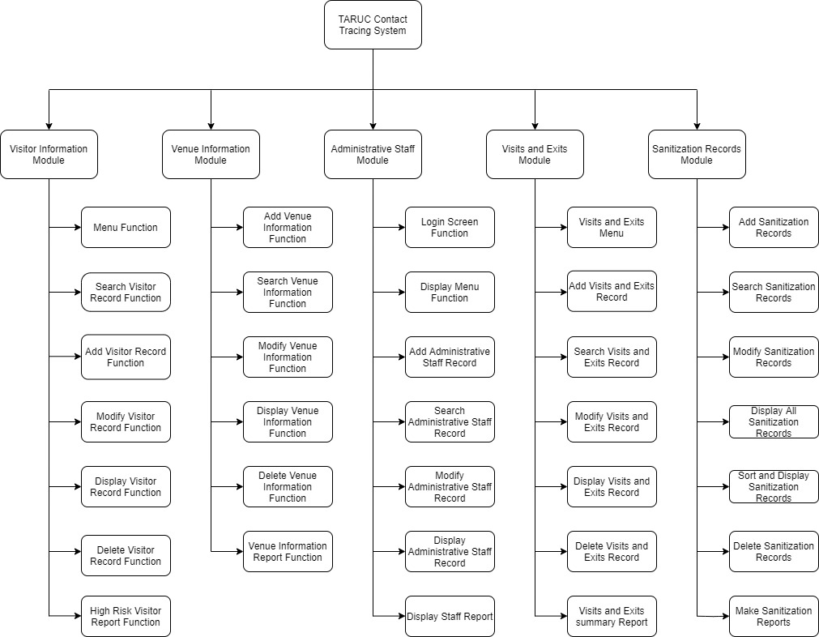

**3.0 Home / Splash Screen**

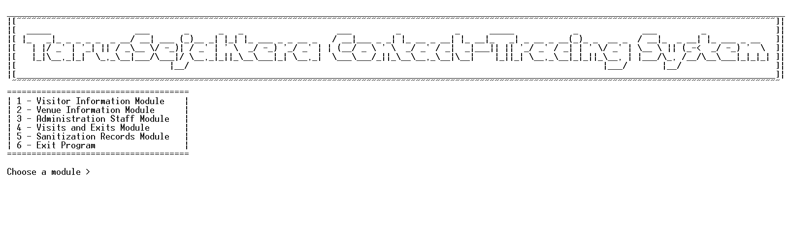

**4.0 System Modules**

**4.1 Visitor Information Module by Tan Eng Lip**

4.1.1 Brief Description

4.1.2 Outputs & File Contents

**4.2 Venue Information Module by Lee Seng Wai**

4.2.1 Brief Description

4.2.2 Outputs & File Contents

**4.3 Administrative Staff Module by Wong Jun Wei**

4.3.1 Brief Description

4.3.2 Outputs & File Contents

**4.4 Visits and Exits Module by Wang Shu Wei**

4.4.1 Brief Description

4.4.2 Outputs & File Contents

**4.5 Sanitization Records Module by Thong So Xue**

4.5.1 Brief Description

4.5.2 Outputs & File Contents

**4.1 Visitor Information Module by Tan Eng Lip**

**4.1.1 Brief Description**

**Function of this module**

This function purpose is to store the visitor’s information which includes data and information such as ID, IC Number, Name, Category, Living Area, Gender, Latest Venue Visited, Register Time, Register Date and Body Temperature. Besides, this module allows the user to access or manipulate the data and information stored via add function, search function, modify function, display function and delete function and high-risk report function.

1. Visitor Information module menu function

This function is the menu function of all 7 functions included in this module that is search visitor function, add visitor function, modify visitor function, display visitor function, delete visitor function , high risk visitor report function and exit function.

1. Add Function

This function will allow the user to add the new visitor’s record. The program will ask users to enter ID, IC Number, Name, Category, Living Area, Gender, Latest Venue Visited and Body Temperature into the program and the registered time and date will use the system date and time. Then the Program will do some validation on the information entered by the user to make sure the information entered is unique and correct. For example, if the ID entered by a user already exists in the records, the user is required to re-enter another ID to ensure the unique id is obtained. If the other information entered is incorrect, the program will ask the user to re-enter the information until a unique and correct information is entered. After the process is completed, the program will save the new records into the visitorInformation.txt file. Users are also allowed to continue entering the new information once the previous record is added successfully. After done all the work in this function, it will go back to the main menu of this module.

1. Search Visitor Function

This function allows the user to search visitor’s records. After entering this function, the program will read the records from the visitorInformation.txt file and prompt a list for users to choose to search by entering the ID, Name, Category, Living Area, Gender or Latest Venue Visited. After choosing, the user is required to enter the related information and the program will search the records that match information entered by the user and show all the details with a proper arrangement. After done all the work in this function, it will go back to the main menu of this module.

1. Modify Function

This function allows the user to modify the visitor’s record that exists in the visitorInformation.txt file. When entered this function, the program will read all the records from visitorInformation.txt file and visitsAndExits.dat file. Then the system will ask the user to enter Visitor ID to search the existing record in the text file and the users can modify IC number, Name, Category, Living Area, Gender and Temperature. Visitor ID, register date, register time and latest venue visited are not allowed to modify as it should not be modified. The program will also validate the information entered by the user to make sure the information entered by the user is correct. Then, a confirmation message will be displayed for the user to modify the records. If the user is confirmed to modify, the program will update the records in the visitorInformation.txt and if any visits and exits records in visitAndExit.dat related with the records modified, the records in the visitsAndExits.dat will also be updated. Users are also allowed to continue to modify the records once the previous record is modified successfully. After done all the work in this function, it will go back to the main menu of this module.

1. Display Function

When entered this function, the program will read all the records from visitorInformation.txt file. Then it will show out all the visitor’s records in the text file that is ID, IC Number, Name, Category, Living Area, Gender, Latest Venue Visited Registered Date, Registered Time and Body Temperature to the user with proper arrangement. After done all the work in this function, a message will be prompted for the user to choose to go back to the main menu of this module or exit the program.

1. Delete Function

This function allows the user to delete the visitor’s record that exists in the visitorInformation.txt file. When entered this function, the program will read all the records from visitorInformation.txt file and visitsAndExits.dat file. Then the system will ask the user to enter visitor ID and search for the records in the text file, if the records exist, a confirmation message will be displayed for the user to confirm delete the records. If the user is confirmed to delete, the program will delete the records in the visitorInformation.txt and if any visits and exits records in visitAndExit.dat related to the visitor ID, the records in the visitsAndExits.dat will also be deleted. Users are allowed to continue delete the records once the previous record is deleted successfully. After done all the work in this function, it will go back to the main menu of this module.

1. High-Risk Visitor Report Function

When entered this function, the program will read all the records from visitorInformation.txt. Then this function will show the report of the high-risk visitor whose body temperature is more than 37.4 °C and visitors that come from the high-risk area and their percentage respectively. This function will also show the percentage of high-risk visitors, percentage of male and female visitors, and the date and time the report generated. After done all the work in this function, a message will be prompted for the user to choose to go back to the main menu of this module or exit the program.

**4.1.2 Output & File Contents**

**Module’s Main Page:**

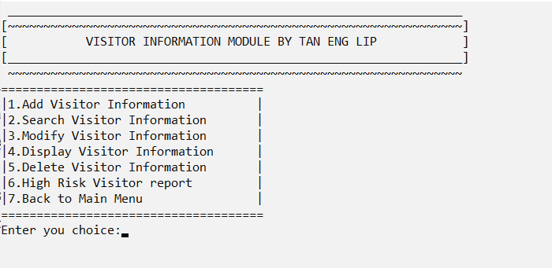

-This image is the main menu of visitor information module

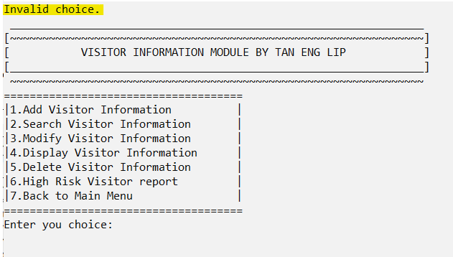

-This image shows the validation when the choice is not between 1 to 7 (Invalid choice)

Data in Text File

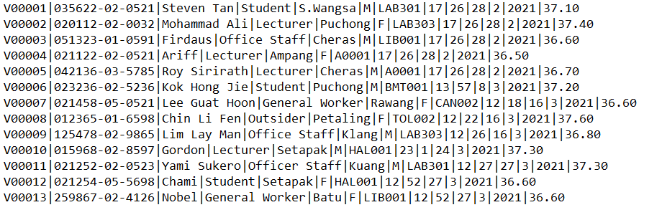

**Add Visitor Function:**

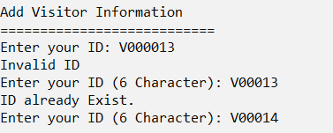

- If the ID is not 6 characters (Invalid ID) or already exists (ID already Exist.)

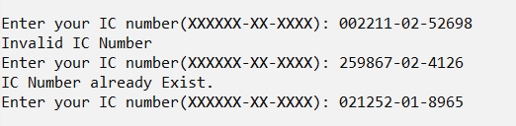

- If the IC Number is more than 14 characters (Invalid IC Number) or the IC number already exists (IC Number already Exist)

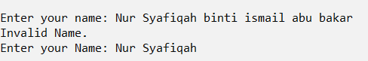 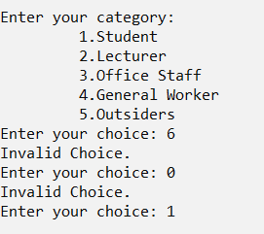

**-** If the name is more than 20 characters (Invalid Name.)

- If the category is more than 6 or less than 1 (Invalid Choice)

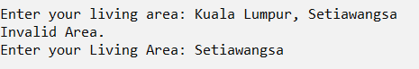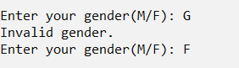

- If the area name is too long (Invalid Area)

- If the gender is not M(m) or F(f). (Invalid gender)

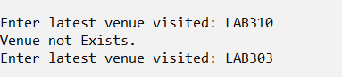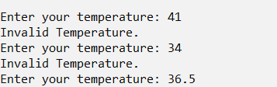

- If the venue ID entered does not exist in VenueInformationRecord.txt (Venue not Exists.)

- If the temperature entered is more than 40 or less than 35. (Invalid Temperature)

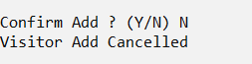

- This is the message shown when confirm add is Y(y) or N(n).

Data in Text File

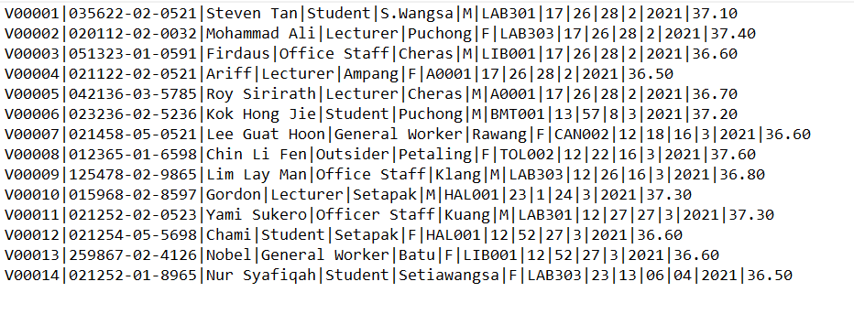

**Search Visitor Function:**

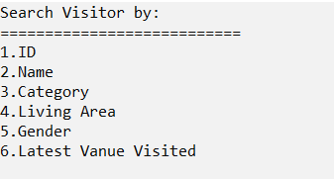

- The search menu for user to choose

Search By ID

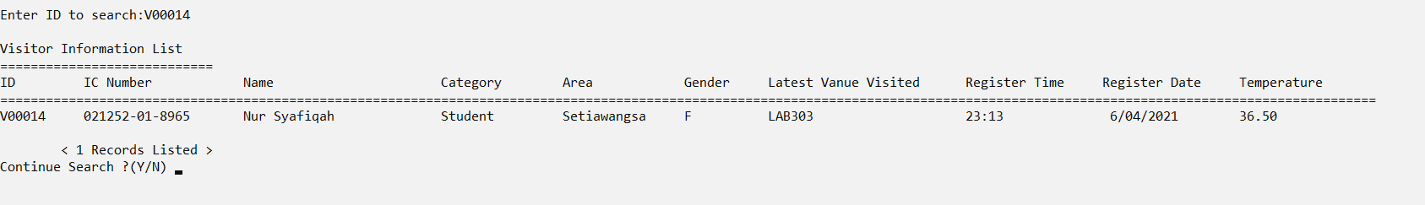

- This picture shows the result of search by ID

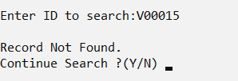

- This picture shows the if the ID search is not exist (Record Not Found.)

Search By Name

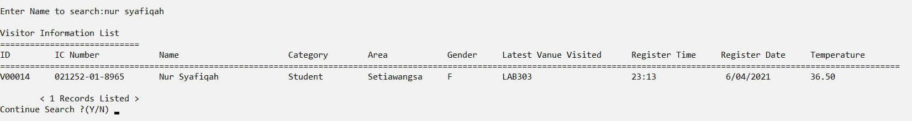

- This picture shows the result of search by Name, when search by name the uppercase or lowercase is ignored.

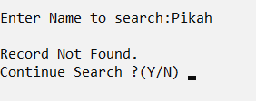

- This picture shows the if the Name search is not exist (Record Not Found.)

Search By Category

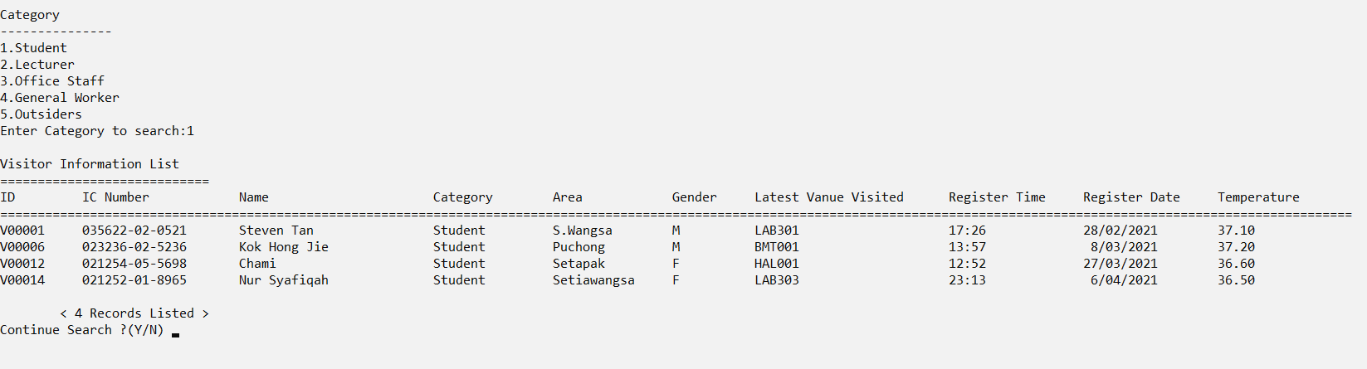

- It will show a menu for the user to choose and will show the result based on the user's choice.

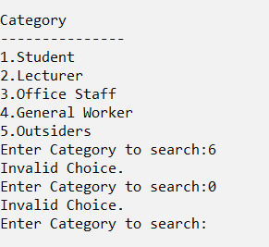

- An error message shows when choice is < 1 or > 6 (Invalid Choice.)

Search By Living Area

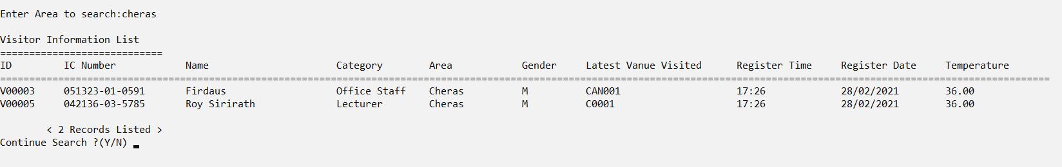

- This picture shows the result of search by Living Area, when search by Area the uppercase or lowercase is ignored.

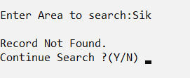

- If Area is not found in the Visitor's Record (Record Not Found)

Search By Gender

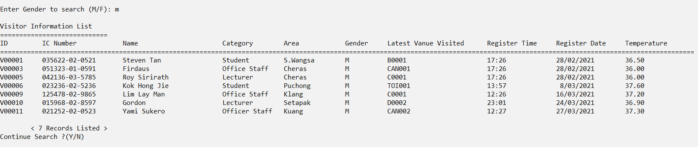

- This picture shows the result of search by Gender, when search by Gender the uppercase or lowercase is ignored.

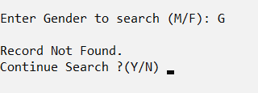

- If Gender is not found in the Visitor's Record (Record Not Found.)

Search By Latest Venue Visited

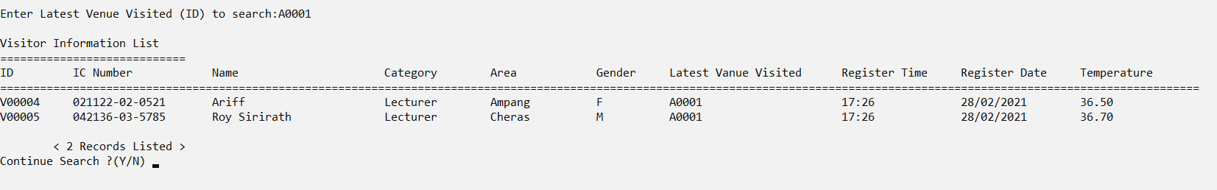

- This picture shows the result of search by Latest venue visited, when search by the latest venue visited the uppercase or lowercase is ignored.

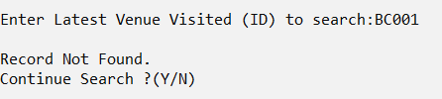

- If the latest venue visited is not found in the Visitor's Record (Record Not Found.)

Data in Text File



**Modify Visitor Function:**

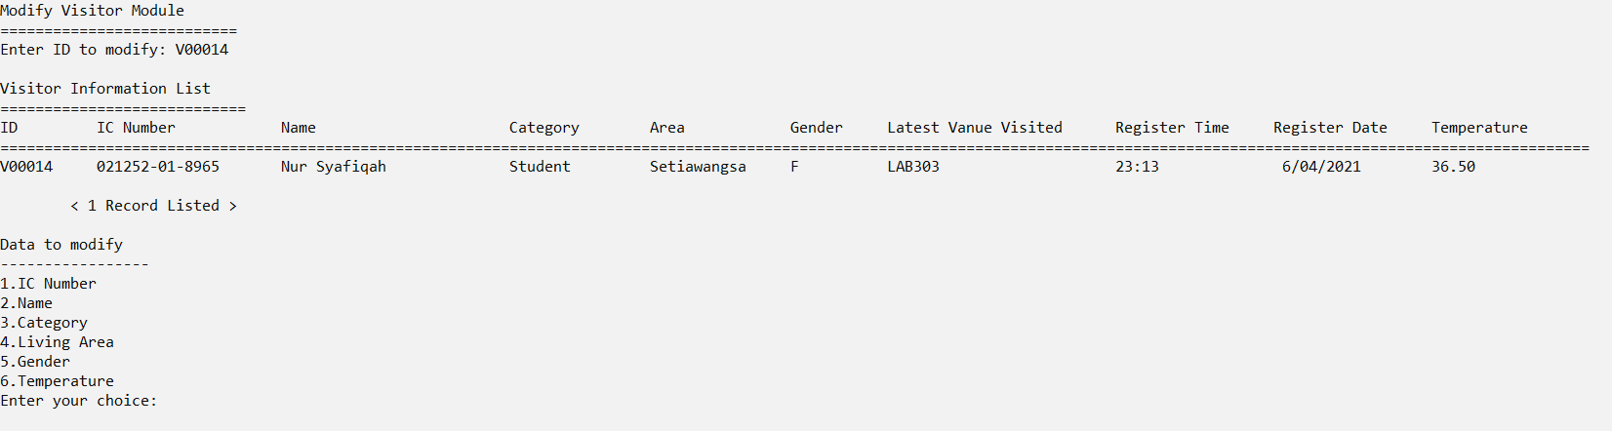

**-** After entering Visitor ID, Visitor Information will be shown and a menu of choice will show out and allow the user to choose. Visitor ID , Register Time , Register Date and Latest venue visited are not allowed to modify.

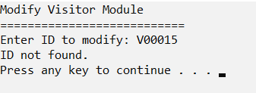

- Picture shows if ID not found from file (ID not found.)

Modify IC Number

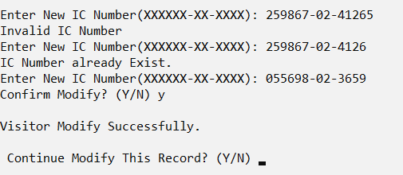

- If the IC Number is more than 14 characters (Invalid IC Number) or the IC number already exists (IC Number already Exist.)

- If the ID exist in visitsAndExits.dat, it will also update the IC number.

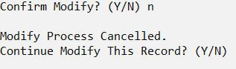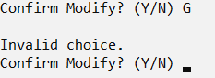

- If confirm modify is N(n) - If confirm modify not Y(y) or N(n)

Modify Name Modify Category

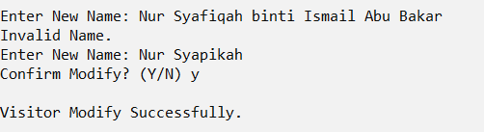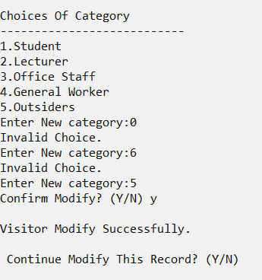

**-** If the name is more than 20 characters (Invalid Name.) - If the choice is not between 1 to 5 (Invalid Choice.)

Modify Living Area Modify Gender

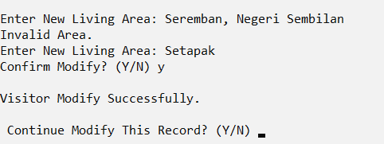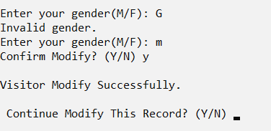

- If the area name is too long (Invalid Area) - If the gender is not M(m) or F(f) (Invalid gender)

Modify Temperature

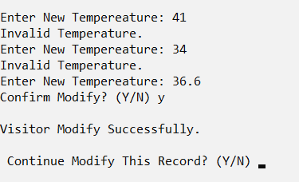

- If the temperature entered is more than 40 or less than 35. (Invalid Temperature)

- If the ID exist in visitsAndExits.dat, it will also update the IC number.

Data in Text File

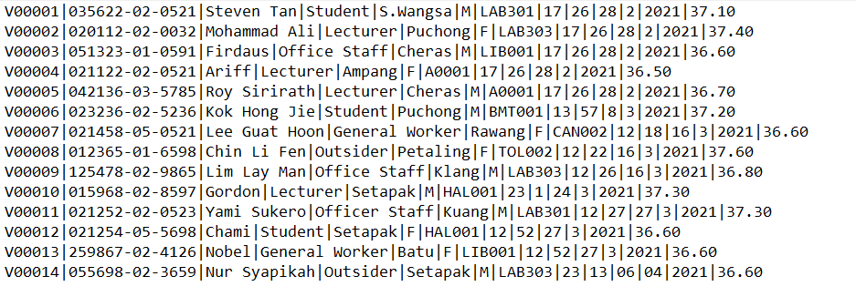

**Display Visitor Function:**

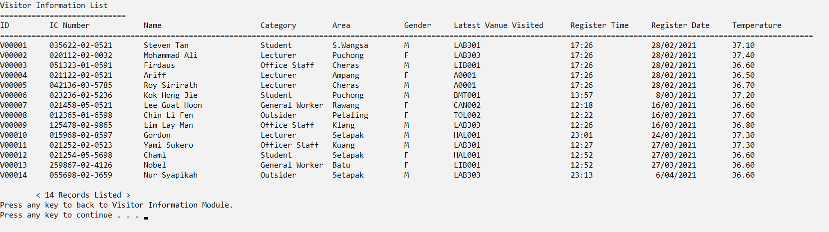

Data in Text File



**Delete Visitor Function:**

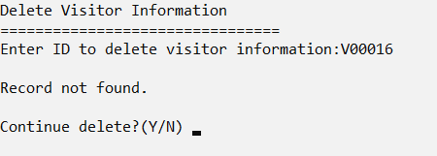

- If ID entered is not found (Record not found)

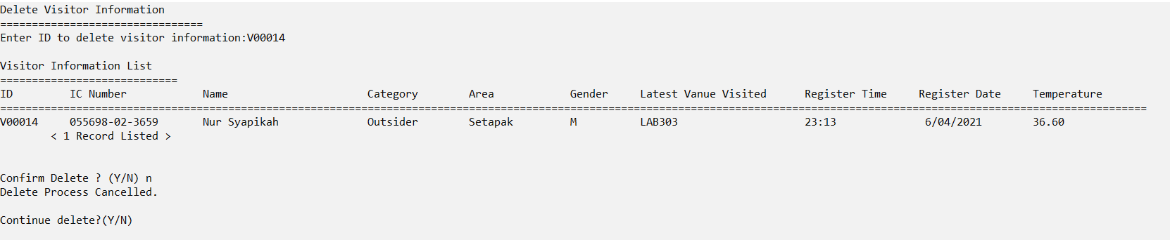

- If confirm delete is N(n) (Delete Process Cancelled)

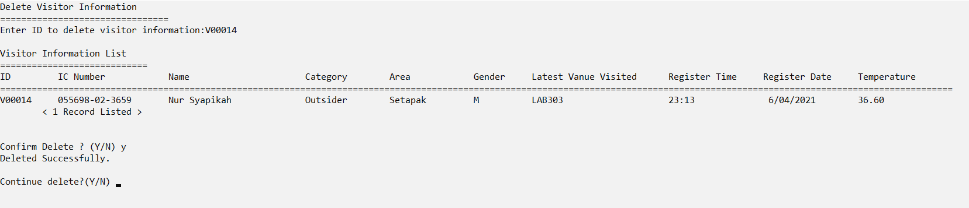

- If confirm delete is Y(y) (Deleted Successfully)

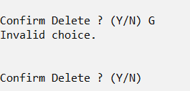

- If confirm delete is not Y(y) or N(n) (Invalid choice.)

Data in Text File

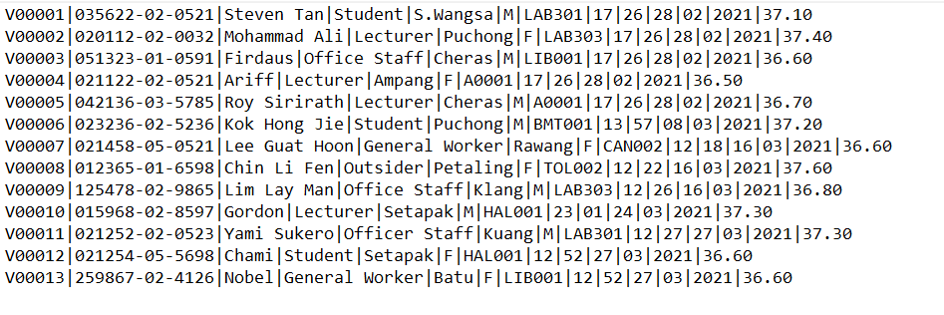

**High-Risk Visitor Report Function:**

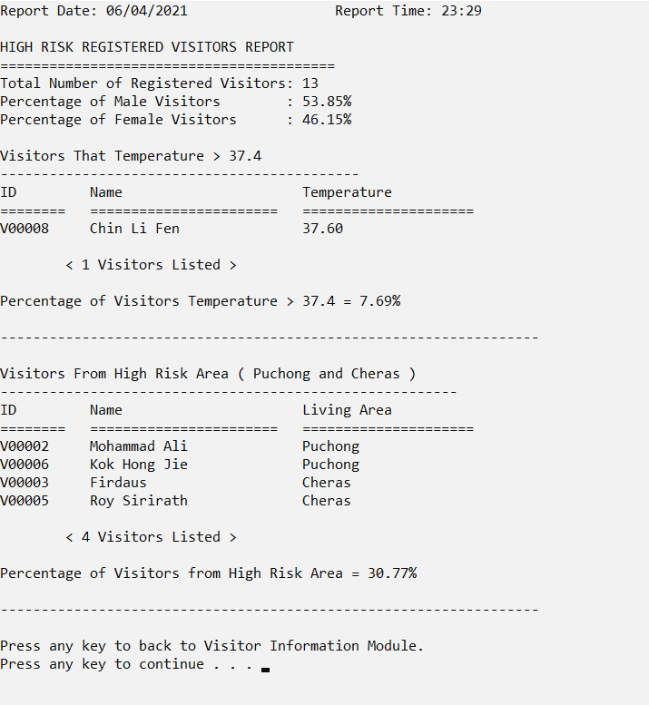

Data in Text File



**4.2 Venue Information Module by Lee Seng Wai**

**4.2.1 Brief Description**

**Function of this module**

This purpose of this function is to store the venue information which includes data and information such as ID, Name, Category, Description, Area Size (sqft), Maximum number of visitors, Current Visitors, Last Sanitization Date and Danger Level. Besides, this module also allows the user to access or manipulate the data and information stored via add function, search function, modify function, display function and delete function and report function.

1. **Add Venue Function**

This function allows the user to add new venue information. The program will ask the user to enter venue ID, Name, Category, Description, Current Visitors, and Last Sanitization Date. Then the program will do some validation on the information that was entered by the user to make sure the information entered is unique and correct. For example, if the user entered the venue ID which is longer than the venue ID range or already exists in the records, the user has to re-enter another venue ID to ensure the unique ID is obtained. After successfully entering all the venue data, the program will save the records into the VenueInformationRecord.txt file. The user also can choose to continue entering new venue information or go back to the main menu of this module.

1. **Search Venue Function**

This function allows the user to search venue records from the VenueInformationRecord.txt file and prompt a list for the user to choose by entering ID, Name, Category or Description.

1. **Modify Venue Function**

In this function, the user is able to modify the venue records from the VenueInformationRecord.txt file by entering ID, Name Category or Description.

1. **Display Venue Function**

When the user enter this function, the program will display all the venue’s information in the text file

1. **Delete Venue Function**
2. **Report Function**

This function allows the user to view the report from the VenueInformationRecord.txt file.

**4.2.2 Outputs & File Contents**

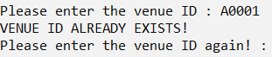

This validation shows that the venue ID has been recorded into VenueInformationRecord.txt.

**4.3 Administrative Staff Module by Wong Jun Wei**

**4.3.1 Brief Description**

**Function of This Module**

The main function of this module is to add, modify and display staff records and information which include Staff ID, Staff Name, Staff Position, Staff Faculty, Staff Password, Staff Contact Number, Staff Salary and Staff Joined date. There are 8 main functions included in this module, which are main screen, menu function, add function, search function, modify function, display function and report function.

1. **Administrative Staff Main Function (administrativeStaffModule)**

At the beginning of this function, it will call loginScreen function to ensure the user is a TARUC administrative staff. Users are required to enter his staff ID and Password. If the id and password is correct then the program will proceed to the next function which is staffMenu function, else users will be asked whether they want to try again or not. If no, the user will be prompted by a thank you message.

1. **Display Menu Function ( staffMenu )**

This function will show the menu of the administration staff module and allow the user to input the option with the value of 1 until 6 only. The option made will be returned to the main function and do selection. If the user input within 1 till 5, the program will call the entire function. If the user input is 6, the program will end and display a thank you message. Other than the 6 number, all input will be considered as invalid input, therefore, users will be requested to input a valid option which is 1 to 6.

1. **Add Staff Function ( addStaff )**

This function will let the user add a new Staff Record. The program will accept staff ID, staff name, staff position, staff faculty, staff password, staff contact number, staff salary and join date from the user. Users need to input ‘Y’ to represent yes to confirm the entire data has been added. After that, the program will ask the user whether they want to add another record or not. If no, it will show how many records added and return to the menu.

1. **Search Staff Function ( searchStaff )**

This function will allow the user to search within the staff records. First of all, users are able to select the data field they would like to search with. For example, input 1 to search with staff ID. There are only 7 options ( password is excluded ) to choose. There is a validation check for the input from the user. If a user enters anything other than 1 - 7, they will be noticed that they inserted an invalid option and ask whether they would like to try again. In a brief explanation of this search function, if the user entered a correct staff ID after selecting 1, the program will show the records in detail such as name , position and so on. The program will also show how many records have been found. After that, the user will be asked whether they want to search with the current data field again. If not, they will be asked whether they want to try to search with another data field. If no, the user will return back to the menu.

1. **Modify Staff Function ( modifyStaff )**

In this function, users are able to modify the staff records that are available. They need to enter the staff ID in order to modify and update the entire record. If the staff ID entered is NOT correct, they can try to enter another staff ID. When the staff ID has been entered is correct, the original record of the entire staff will be shown except for password. The user needs to do a confirmation that they want to edit the staff based on the record given. Then, the user is able to choose which data they would like to modify. After inputting the new data, users need to confirm their update to save the new record. After that, users will be asked whether they want to change any other data for the entire staff. If no, they will also be asked whether they want to modify another staff record. If no again, they will return back to the menu.

1. **Display Staff Function ( displayStaff )**

In this display function, users will first be asked which type of records they like to read. Either with or without subject. A validation check will be done as well to ensure the input is valid. Records with subject is with the title such as “Staff ID”, “Staff Name” while without subject means the data will be shown directly. If a user chooses a record with subject at first, they will be given a chance to print the record without subject as well.

1. **Display Report Function ( staffReport )**

In this function, users are able to select the type of report ( 1 - 4 ). Of course there is a validation check. A neat report about the administrative staff will be generated according to the user option. Users will be asked again and again do they want to generate another report. If no, they will return back to the menu.

**4.4.2 Output & File Contents**

**File’s Existing Data**

DATA FORMAT :

staffId, name, position, faculty, password, contactNumber, salary, joinDate

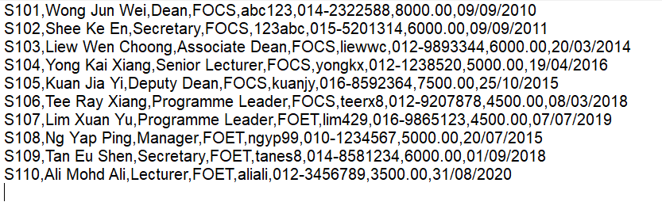 Image 1

**Administrative Staff Module’s Main Page ( Login Function )**

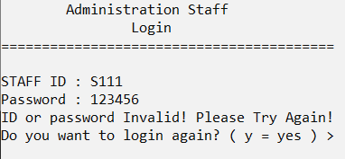 Image 2

Image 2 is showing the Main page of the administrative module which is a login function. Based on

Image 2, the staff ID and Password entered is not correct compared to Image 1. Therefore, we can try login again by entering ‘Y’.

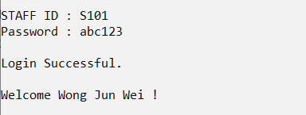 Image 3

Image 3 shows that Login is Successful and welcomes the user.

**Display Administrative Staff Menu**

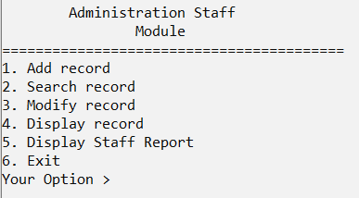 Image 4

Image 4 is the menu of the administrative staff module. And also this is the beginning of the journey. Now the program will proceed by entering ‘1’ as option.

**Add Administrative Staff**

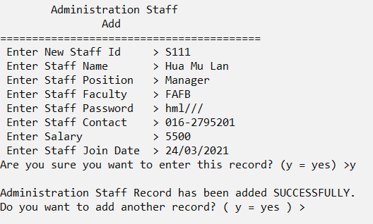 Image 5

Image 5 is showing the process of entering data by using the add function. After entering the data, a confirmation message will be displayed to do a double confirm with the user if they really want to add the record and there is no error. After the user confirmed to add the record, a success added message will be displayed. The program will be continued by asking the user whether they want to add another record. In this case, we are going to enter ‘n’ to exit the add function.

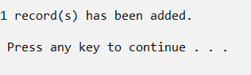 Image 6

Image 6 shows how many records have been added and continue the program by returning to the menu as shown in image 4. But this time we will proceed by entering ‘2’.

**Search Administrative Staff**

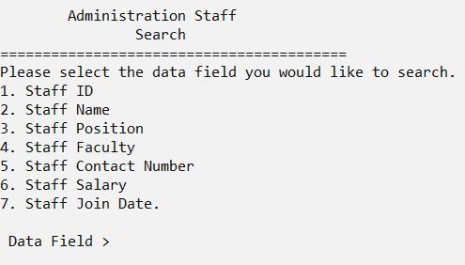 Image 7

Image 7 shows the UI of the search function. Users are requested to enter which data field used to search the records. Now, i will purposely enter a number other than 1 - 7 to show the validation check.

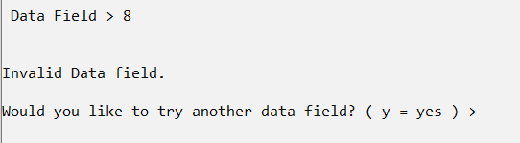 Image 8

Image 8 is showing the result after entering an invalid option.

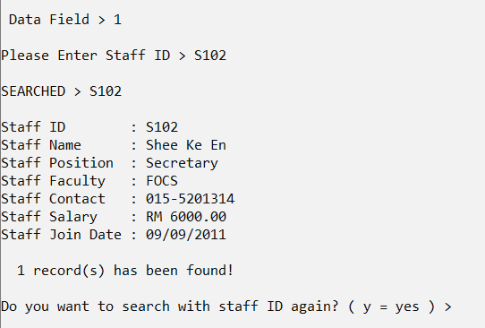 Image 9

Image 9 is continued from Image 7 by entering ‘1’ ( use staff ID to search ). After Entering a correct Staff ID, the record of the staff will be displayed and the total number of records found will also be displayed. Next I will search with staff ID again by input ‘Y’ but entering an invalid staff ID.

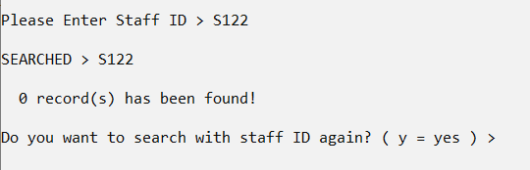Image 10

As you can see, 0 record(s) has been found. Next, we will search with contact number as it is a little bit different from the others.

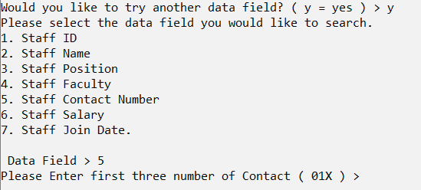 Image 11

By searching with contact number, we just need to input the first three numbers such as 012 to view all the staff records which have a phone number starting from 012.

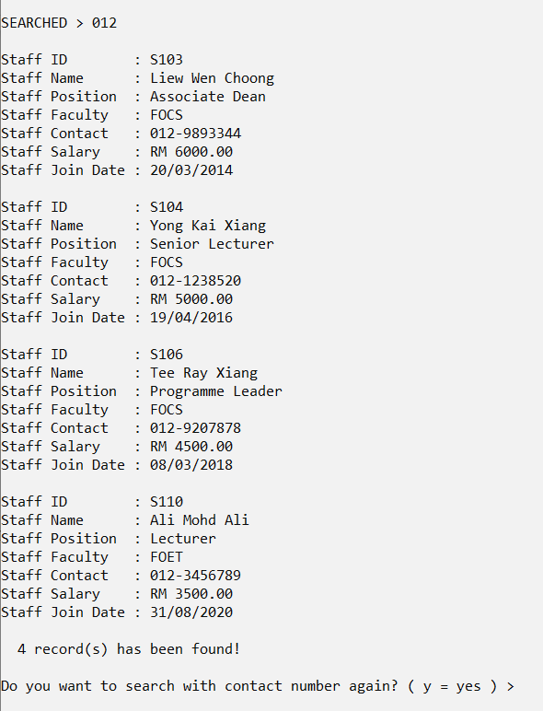 Image 12

Image 12 shows the result after searching the contact number starting from 012.

**Modify Administrative Staff**

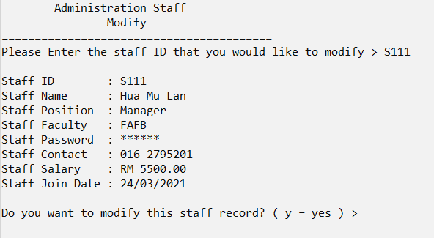 Image 13

Now, we are going to modify the record that we just added in image 5. Image 13 shows the staff record after I entered “S111” and asked if this was the staff record I wanted to modify.

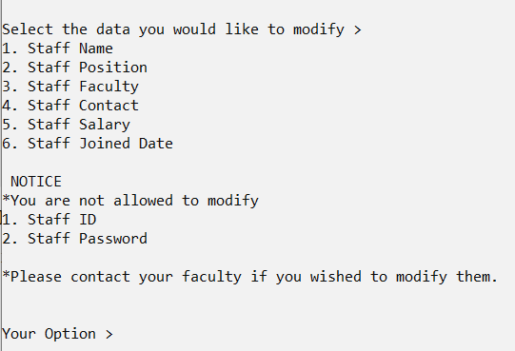 Image 14

An option is shown as Image 14. Users able to modify these data. There is also a notice for the user who wishes to modify the Staff ID and Password.

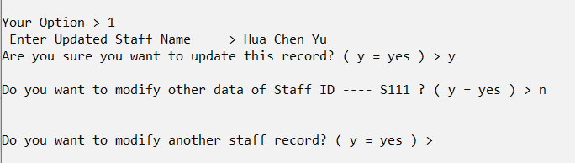 Image 15

I have selected to modify the staff name by entering ‘1’. I keyed in “ Hua Chen Yu ” to replace “ Hua Mu Lan ”. Then a confirmation message will be displayed. Next, users will be asked whether they want to modify other data of this entire staff or not followed by do they want to modify another staff.

 Image 16

If there is no more data to modify, an updated message will be prompted.

**Display Administrative Staff**

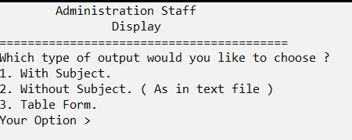 Image 17

Image 17 is showing the question to the user to select which type of output wanted. Part of the result of entering ‘1’ will be shown in the next image while the whole result for “without subject” type will be displayed too. And lastly is the table form.

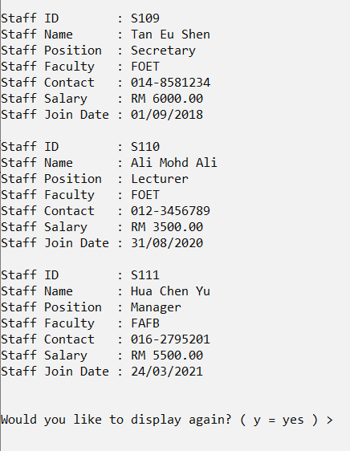 Image 18

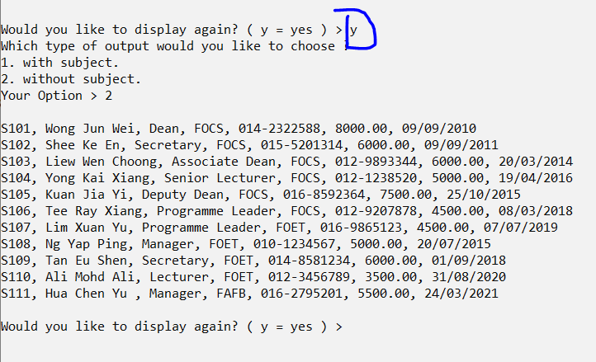 Image 19

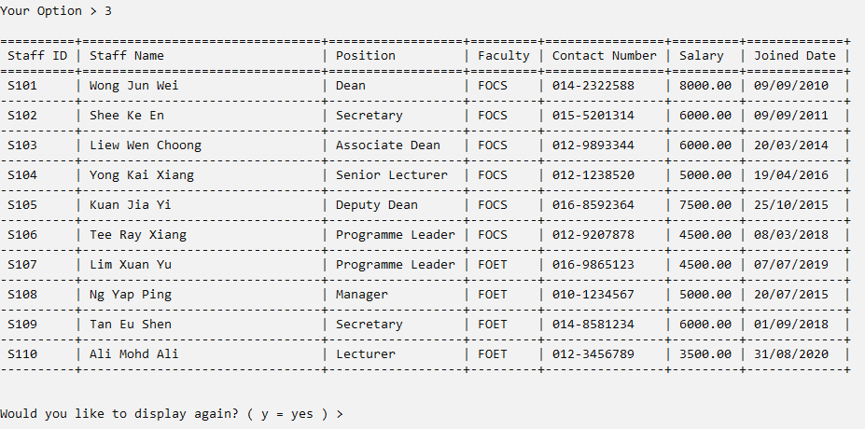Image 20

**Display Administrative Staff Report**

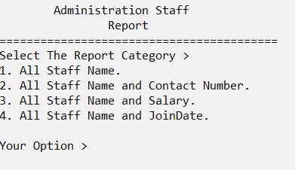 Image 21

Image 21 shows the Report Category for users to choose. All of the reports will be shown in the following images. For report 1, image number is 21.1, for report 2, image number is 21.2 and so on.

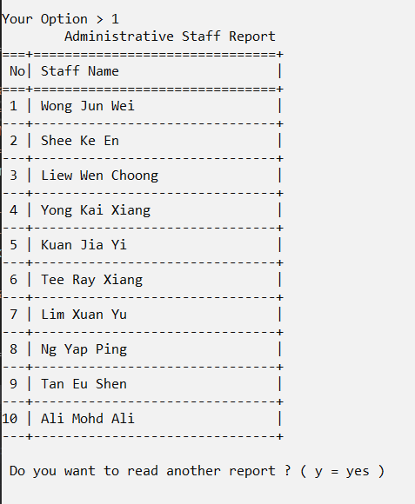Image 20.1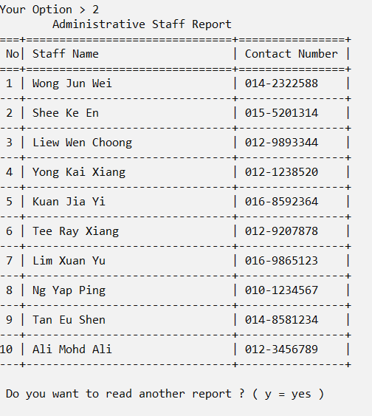Image 20.2

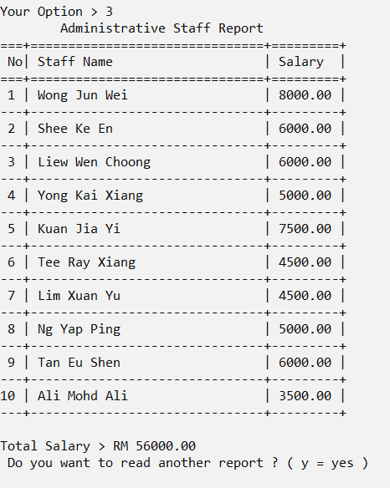Image 20.3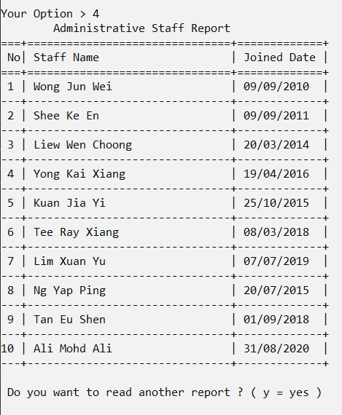Image 20.4

**End of the Program**

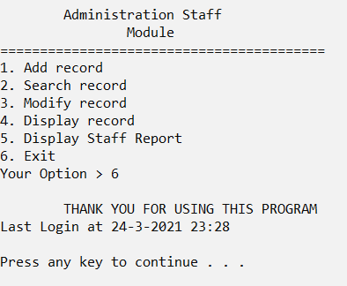Image 21

Image 21 showing the exit option (6) at the menu. And the program comes to the end.

**EXTRA SCENE**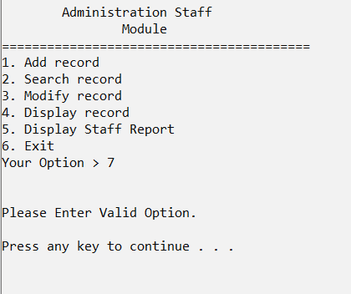

Validation Check at menu

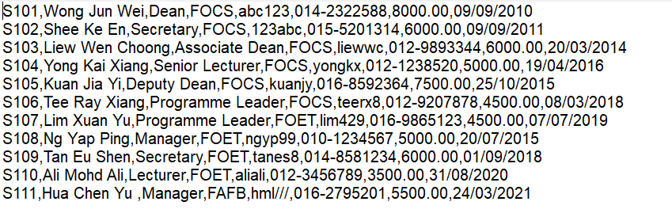 Result of text file

**4.3 Visits and Exits Module by Wang Shu Wei**

**4.4.1 Brief Description**

**Function of This Module**

The main function of this module is to store, maintain and record visits and exits information which include visitor id, visitor ic number, date entered, time entered, time exited, duration of stay, venue id, and visit purpose. There are 6 main functions included in this module, which are display function, add function, search function, modify function, delete function and report function.

1. **Visits and Exits Main Function (visitsAndExitsModule)**

At the beginning of this function, it will call visitsAndExitsMenu function to get the option from the user for accessing the functions of visits and exits module. If the user’s option is 1 until 6, the system will call the display, add, search, modify or report functions based on the value of the user’s option. If the value of the user's option is 7, it will exit from the visits and exits module and back to the system main page.

1. **Display Menu Function (visitsAndExitsMenu)**

This function will show the menu of visits and exits module and allow the user to input the option with the value of 1 until 7 only. After the user has entered the option, the system will do a validation to check the input value whether it is between 1 to 7 or not. If not, the system will display an error message and ask the user to input again. Lastly, if the option is valid, this function will return the option’s value.

1. **Display Records Function (displayVisitsAndExitsRecords)**

Firstly, the function will read all the records of visits and exits from a binary file named ‘visitsAndExits.dat’ and display these records on screen which include visitor id, visitor ic number, date entered, time entered, time exited, duration of stay, venue id, and visit purpose. Sometimes if the visitors haven’t exited the venue yet, it will display the dashes ‘--’ at the time exited and duration of stay’s columns instead of the values. After all the records are displayed, the users will need to enter ‘y’ to quit this display page. Validation will also be done if the user enters a value other than ‘y’. After that, it will go back to the main page of visits and exits module.

1. **Add Records Function (addVisitsAndExitsRecords)**

This function will allow the user to add the visits and exits records. First, the user can choose whether he or she wants to add the records of visits or exits. If the user chooses to add visits’ records, the user should make sure that the ic number of visitor has been registered through the visitor module before adding the visits’ records, if not, the user will not be able to add the records. Besides, the user is not allowed to add visits records at night (00:00 - 05:59) as the visitor can only visit the venues in the morning until evening. For this add visits function, the user can add the venue ID, visit purpose and temperature of this visitors’ ic number. Venue ID will validate from venue information records and the user will need to enter again if they do not match. After that, the date and time entered will be also recorded based on the system date instead of entered by the user. Lastly, the visit record will be stored into the visits and exits binary file and the time exited and duration of stay will be stored with a value of ‘-1’ temporarily. Besides, the venue ID and visitor’s temperature will also be updated into visitor information text file as latest venue visited and temperature. Apart from that, if the user chooses to add exits’ records, the user should make sure that the ic number of visitor has been recorded in visits records before adding the exits’ records. The time exited will be recorded based on the system date instead of entered by the user. Besides, the duration of stay will be also calculated and stored into the records. Lastly, the records will be stored back to the binary file with the values of time exited and duration of stay to replace the value of ‘-1’ that was stored before. At the end of this function, it will return to the main page of visits and exits module.

1. **Search Records Function (searchVisitsAndExitsRecords)**

First, the function will read all the records from the binary file named ‘visitsAndExits.dat’. After that, it will allow the user to search by visitor id, visitor ic number, date entered, visitor temperature, or venue id and display all the details based on the information inputted by the user. If user chooses to search by date entered, the value of date entered inputted will be validated through Date Validation Check function. Last, it will return to the main page of visits and exits module if the user stops searching.

1. **Modify Records Function (modifyVisitsAndExitsRecords)**

Firstly, the function will read all the records from the binary file named ‘visitsAndExits.dat’. After that, it will allow the user to search by visitor id or visitor ic number of the records that he or she wants to modify. If there are more than 1 record found of the visitor id or visitor ic number, users can choose to modify one of these records by entering its sequence number. The user is able to modify the date entered, time entered, time exited, temperature, venue id and visit purpose. However, if the exit information hasn't been recorded yet, the user is not allowed to modify the time exited. Venue ID will validate from venue information records and the user will need to enter again if they do not match. All of the date and time entered by the users will also be validated through Date Validation Check function and Time Validation Check function. If date and time are not valid, the user will need to enter again until they are valid. After the users have modified the record, the system will display the record for users’ confirmation before storing it into the binary file. Besides, the venue ID and visitor’s temperature will be also updated into visitor information text file as latest venue visited and temperature Lastly, it will return to the main page of visits and exits module if the user stops modifying.

1. **Delete Records Function (deleteVisitsAndExitsRecords)**

Firstly, the function will read all the records from the binary file named ‘visitsAndExits.dat’. After that, it will allow the user to search by visitor id or visitor ic number of the records that he or she wants to delete. If there are more than 1 record found of the visitor id or visitor ic number, users can choose to delete one of these records by entering its sequence number. At the end of this function, it will return to the main page of visits and exits module if the wish to stop deleting the records.

1. **Report Function (reportVisitsAndExitsRecords)**

Firstly, the function will read all the records from the binary file named ‘visitsAndExits.dat’.

After that, it will calculate and display a report that contains the total number of all visits, total number of today’s visits, number of current visits of today and its percentage, number of previous visits of today and its percentage, and also the number of high risk visits of today and its percentage. Besides, it will also calculate and display the percentages of the visits for each time frame in the report. Lastly, it will return to the main page of visits and exits module after the report has been displayed.

**4.4.2 Output & File Contents**

**Visits and Exits Module’s Main Page**

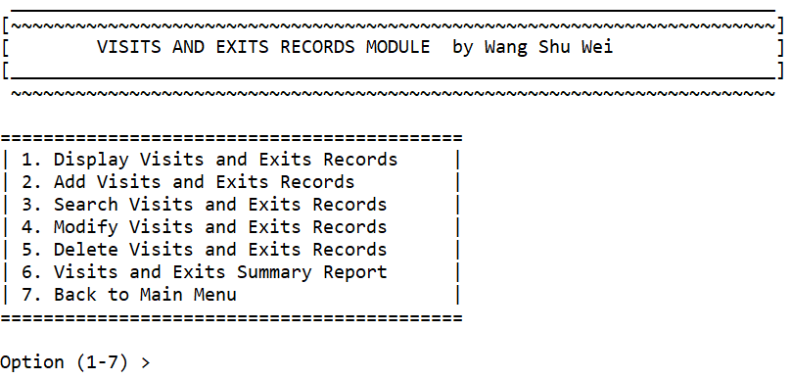

This image shows the main page of Visits and Exits Module.

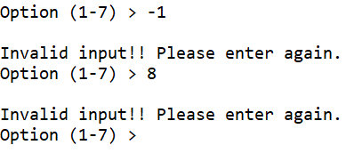

This image shows the validation of entering the option other than 1 - 7.

**Display Visits and Exits Records**

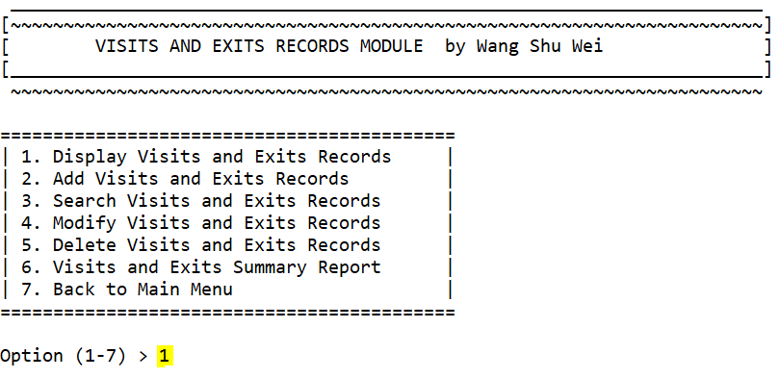

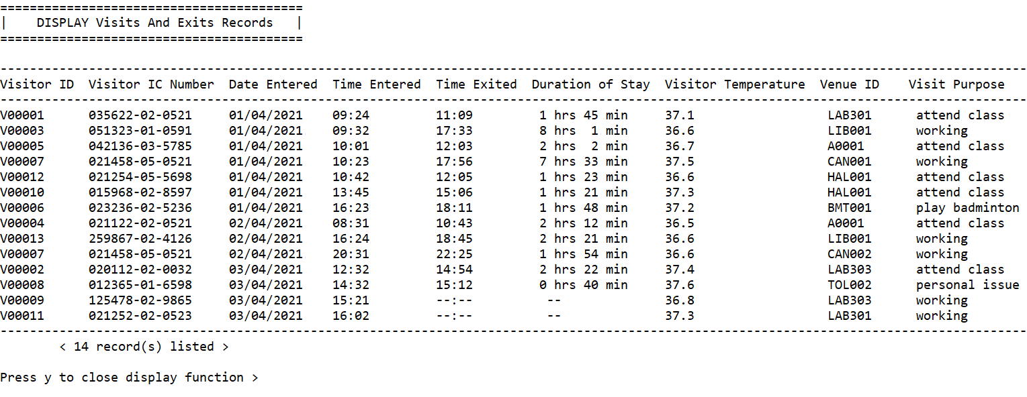

These two images show if user enters 1 for DISPLAY visits and exits records. After that, user should press ‘y’ to close the display function.

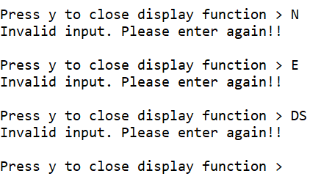

This image shows the validation of user input to close the display function.

**Add Visits and Exits Records**

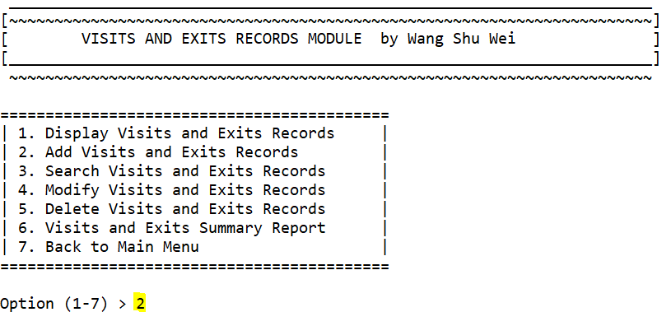

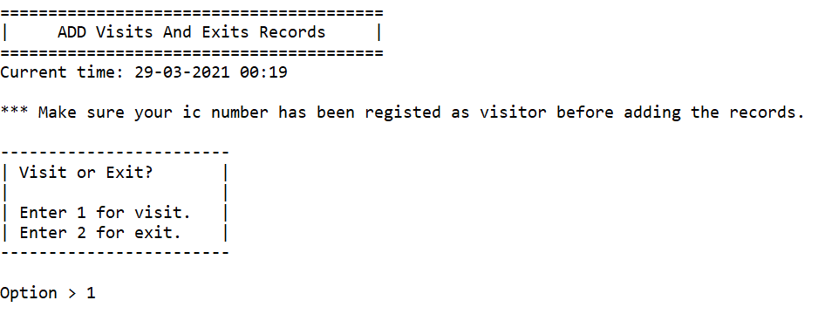

These two images show that if user enters 2 in the visits and exits menu, it will display ADD function. User can choose 1 for adding visit’s records or 2 for adding exit’s records.

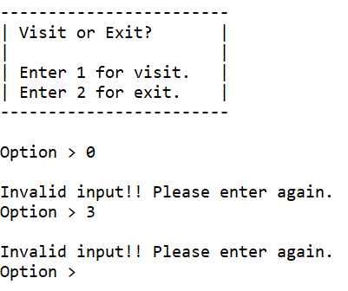

This image shows the validation of entering the option other than 1 and 2.

Add Visit Record

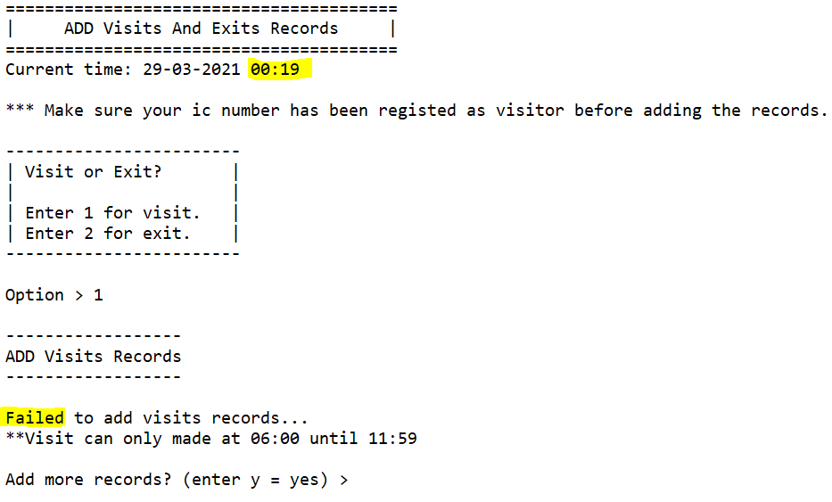

This image shows that the add visits function will be closed at night (00:00 - 05:59). This is because the visitor can only visit in the morning until evening.

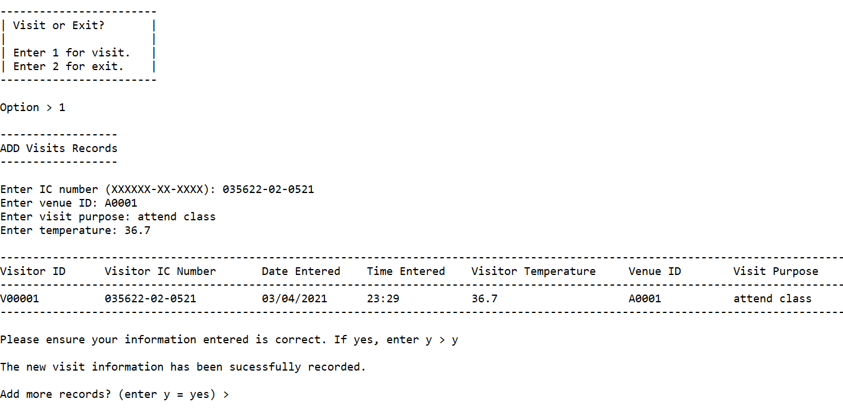

This image shows the screen if the user chooses 1 for adding visit’s records. First, user needs to enter his or her ic number. If the ic number has been registered as a visitor before, so that the user can continue to input the visit’s information. After that, it will display the record for user’s confirmation before being stored into the file. Lastly, it will allow the user to continue adding records by entering ‘y’.

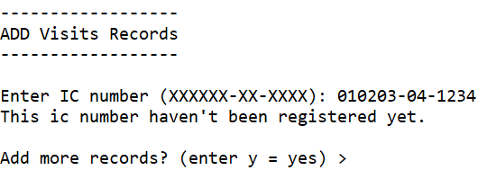

This image shows if the ic number entered by the user has not been registered as a visitor yet.

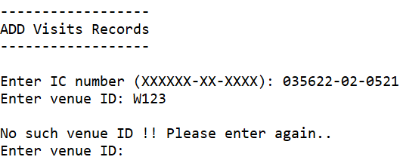

This image shows the validation of venue id. If the venue id is not found in venue’s information records, it means that the venue id is invalid and the user will need to enter a valid venue id again.

Add Exit Record

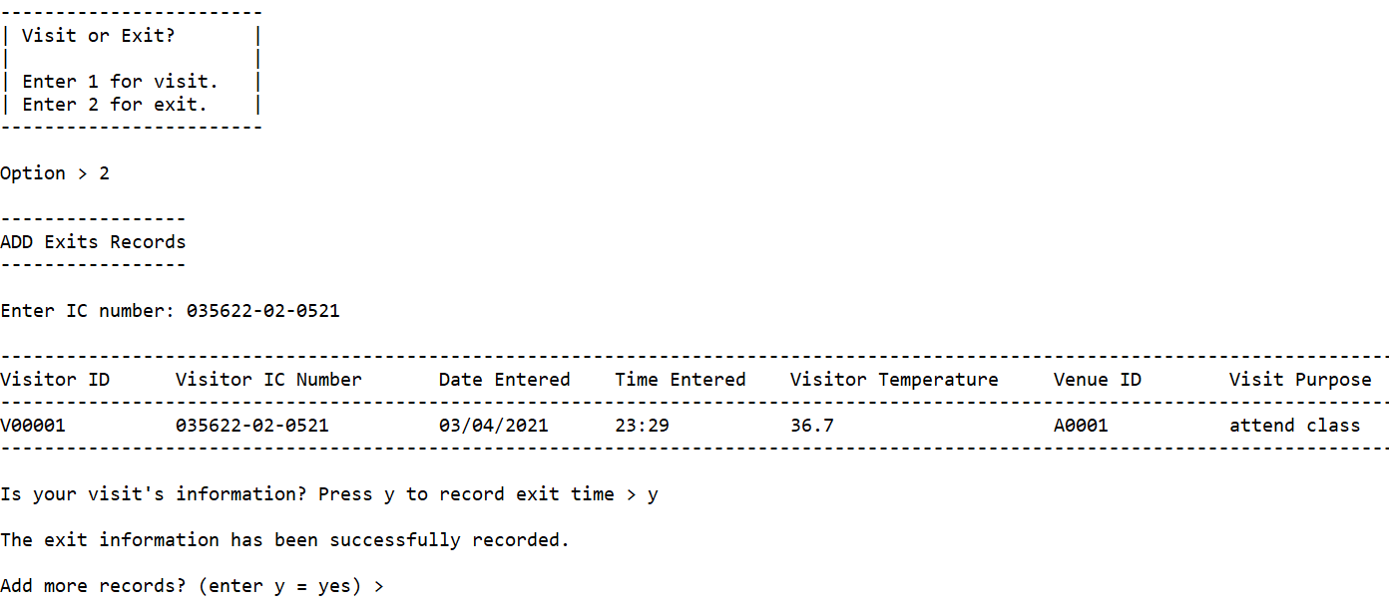

This image shows if user chooses 2 for adding exit’s records. First, user needs to enter his or her ic number which ic number should be recorded in visit’s records and the time exited has not been recorded yet. After that, the user will need to enter ‘y’ to record the time exited. Lastly, it will allow the user to continue adding records by entering ‘y’.

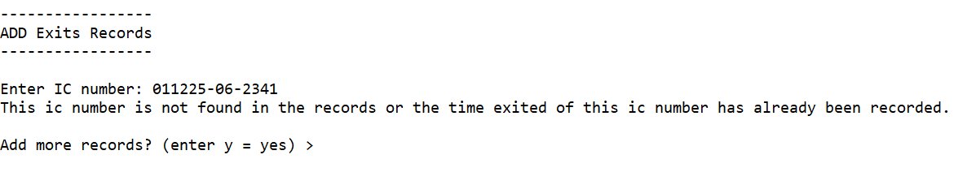

This image shows if the ic number entered by the user is not found in visit’s records or the time exited of this record has been recorded.

**Search Visits and Exits Records**

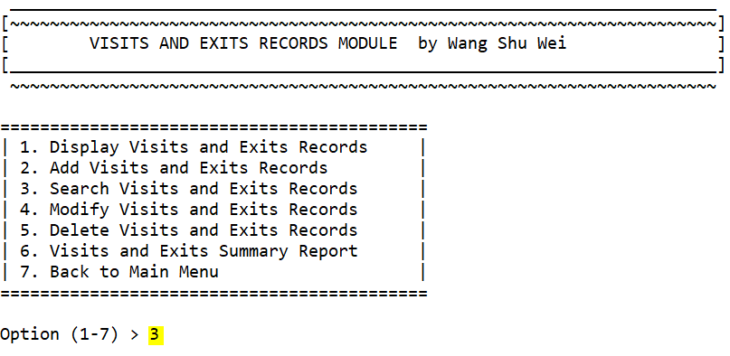

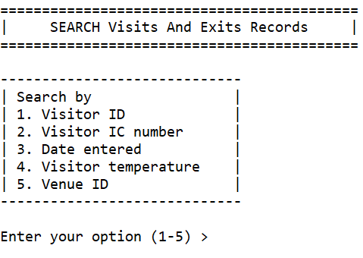

These two images show that if user enters 3 in the visits and exits menu, it will display SEARCH function.

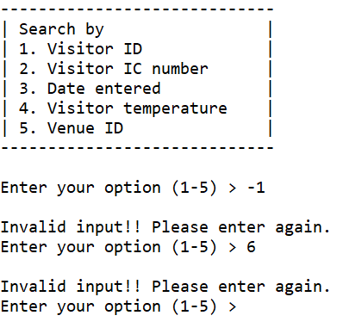

This image shows the validation of entering the option other than 1 - 5.

Search by Visitor ID

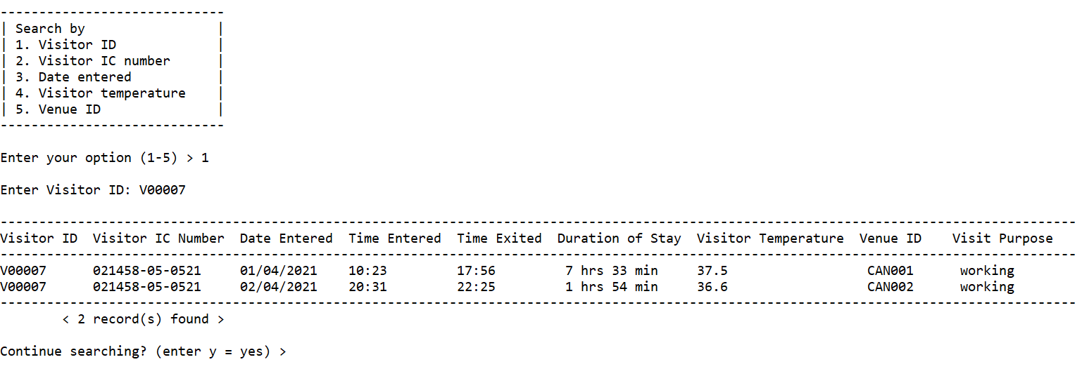

This image shows the output if user chooses 1 for searching by visitor id.

Search by Visitor IC Number

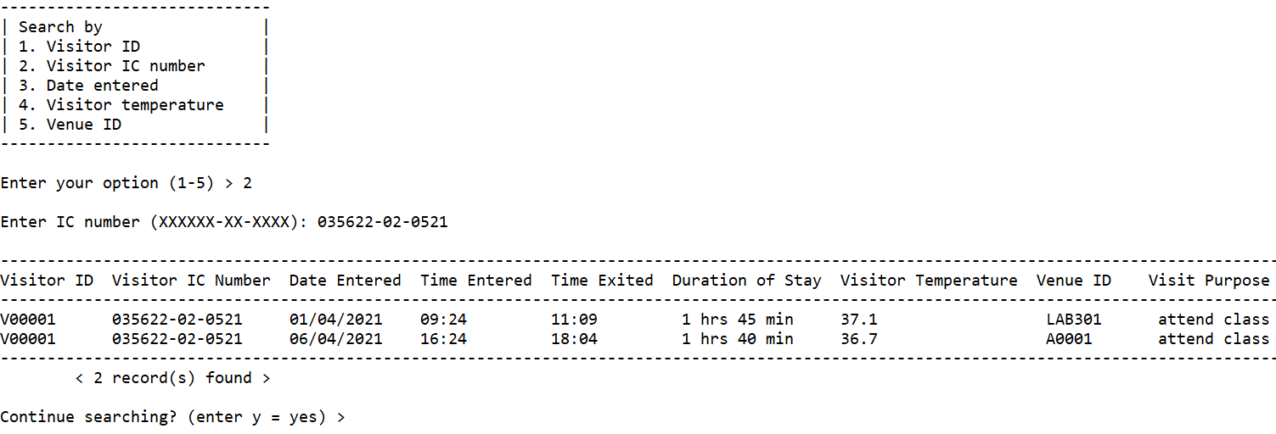

This image shows the output if user chooses 2 for searching by visitor ic number.

Search by Date Entered

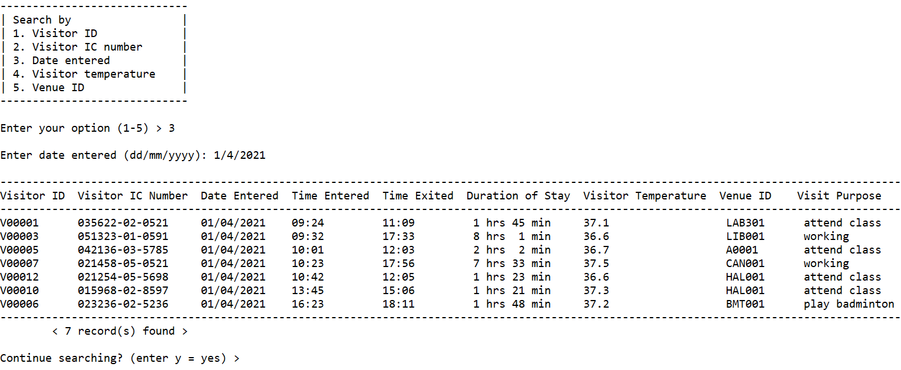

This image shows the output if user chooses 3 for searching by date entered.

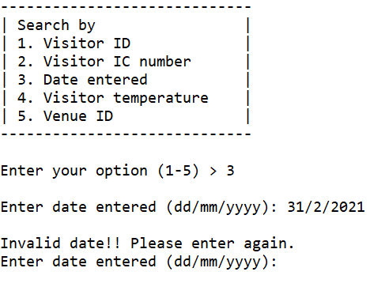

This is the validation of date entered inputted by the user. For example, there is no such day of 31th in February as this image shows above.

Search by Visitor Temperature

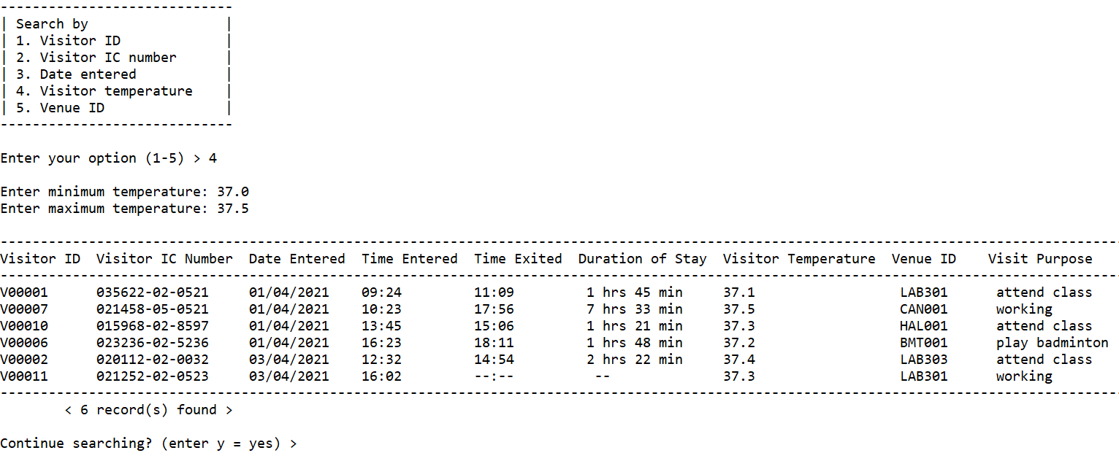

This image shows the output if user chooses 4 for searching by visitor temperature .

Search by Venue ID

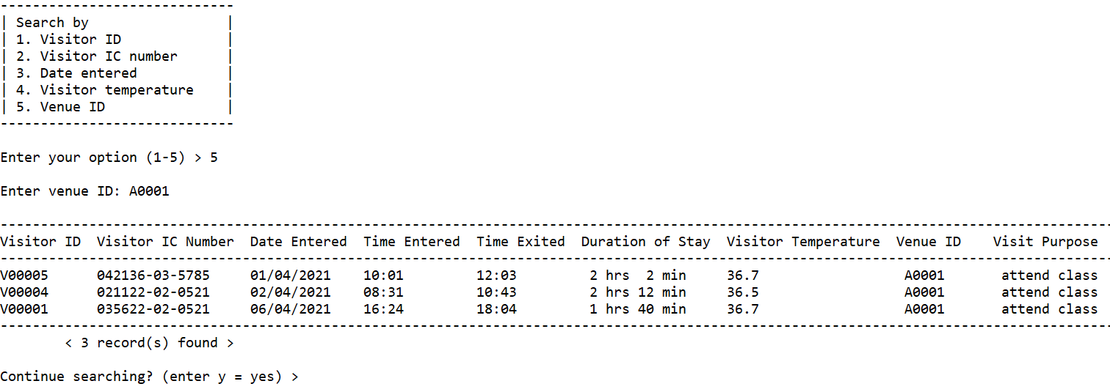

This image shows the output if user chooses 5 for searching by venue id.

**Modify Visits and Exits Records**

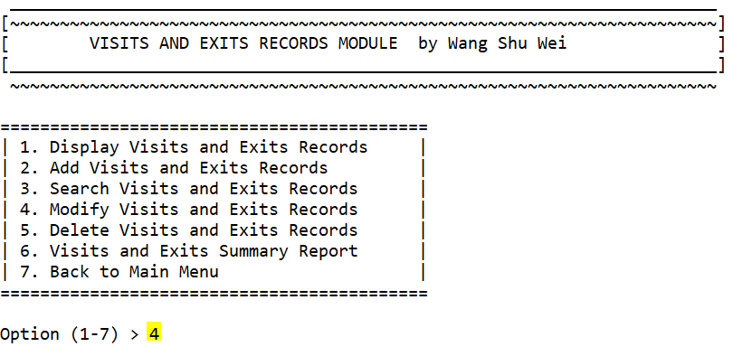

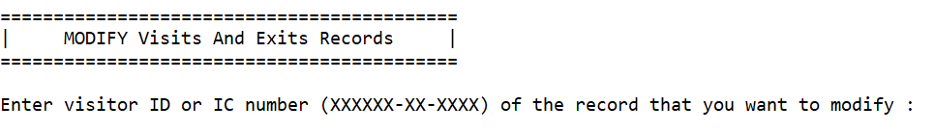

These two images show that if user enters 4 in the visits and exits menu, it will display MODIFY function.

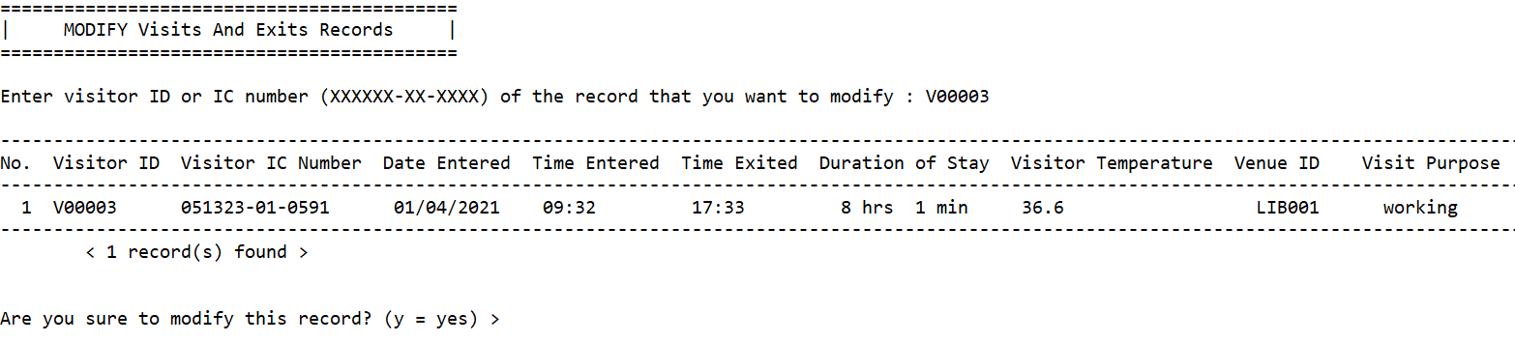

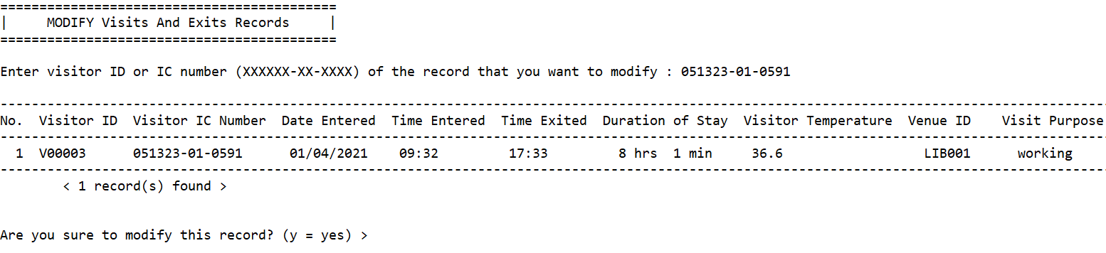

These two images show that the user can either search by visitor id or ic number for modifying the certain record.

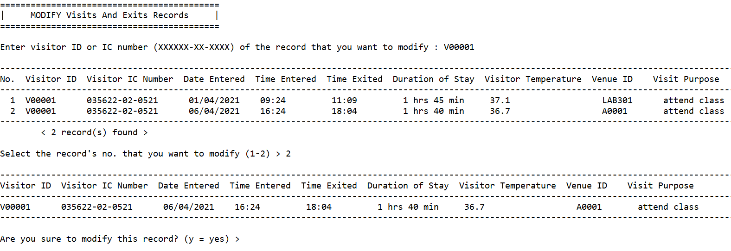

This image shows that if there are more than 1 records found by the visitor id, the user can select one of them for modifying by entering its sequence number.

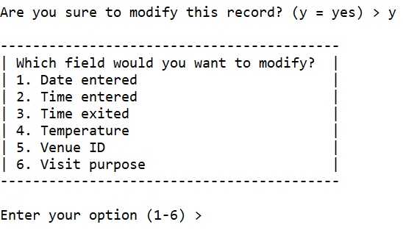

This image shows that if user wants to modify the record, it will let the user choose what field that he or she wants to modify.

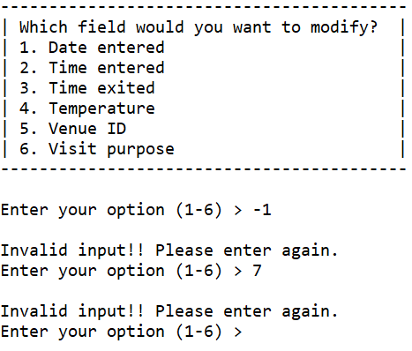

This image shows the validation of user’s option when its value is other than 1 - 6.

Modify Date Entered

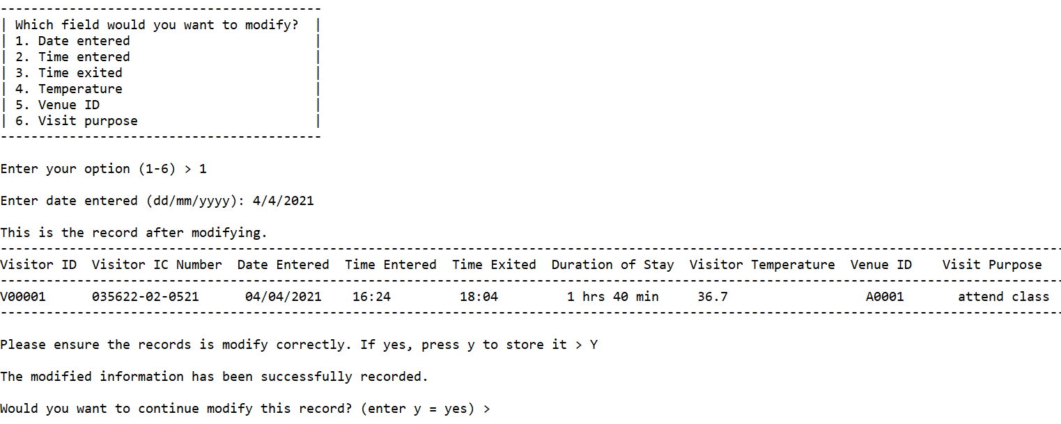

This image shows the output if user chooses 1 to modify date entered.

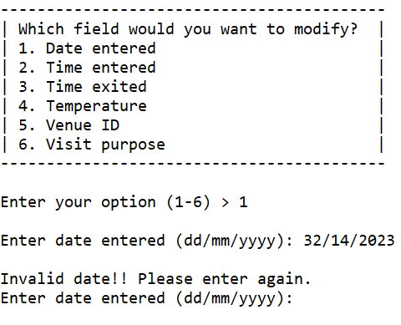

This image shows validation of the value of date entered inputted by user.

Modify Time Entered

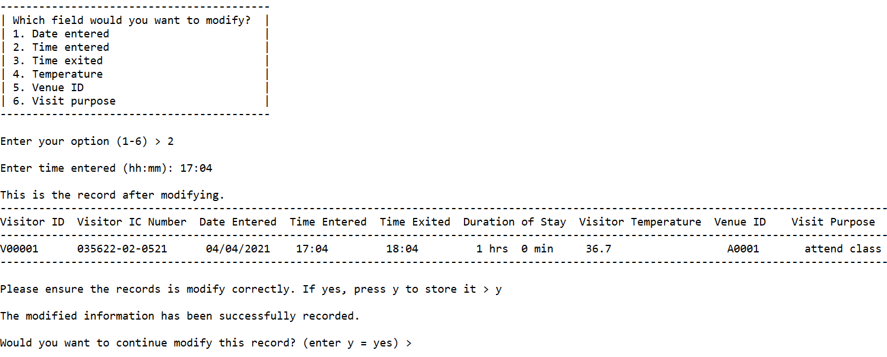

This image shows the output if user chooses 2 to modify time entered.

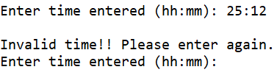

This image shows validation of the value of time entered inputted by user.

Modify Time Exited

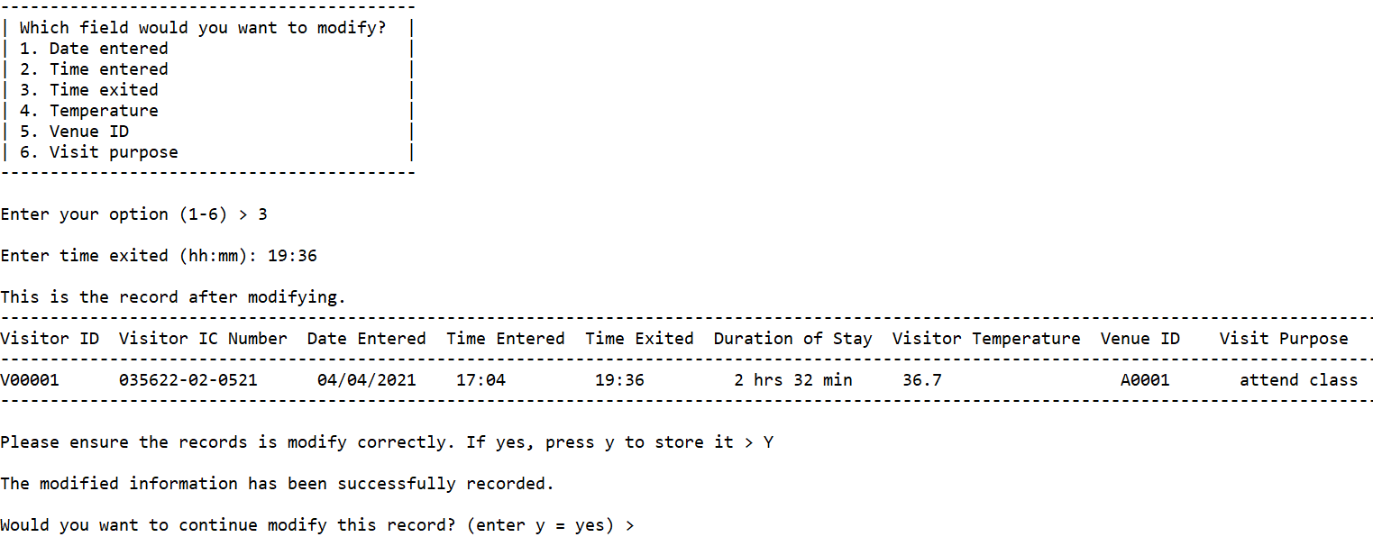

This image shows the output if user chooses 3 to modify time exited.

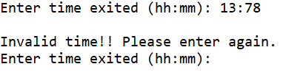

This image shows validation of the value of time exited inputted by user.

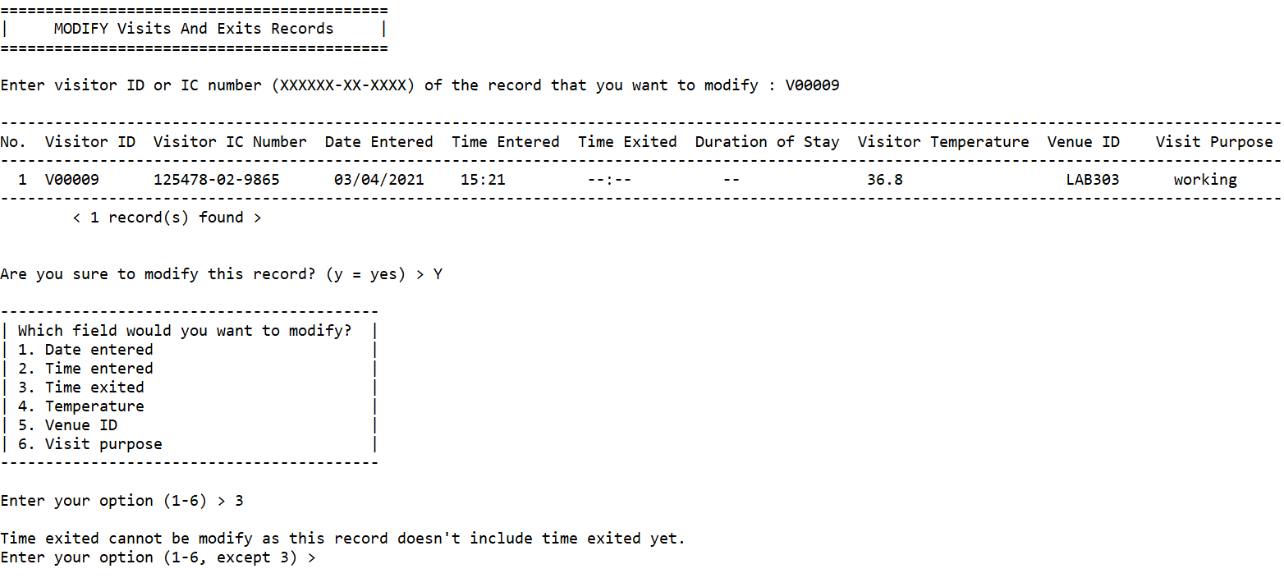

This image shows that if time exited and duration of stay haven’t been included in the record, the user is not allowed to modify the time exited.

Modify Temperature

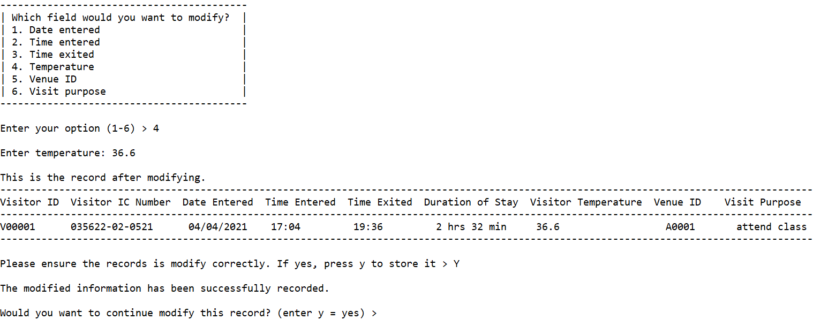

This image shows the output if user chooses 4 to modify temperature.

Modify Venue ID

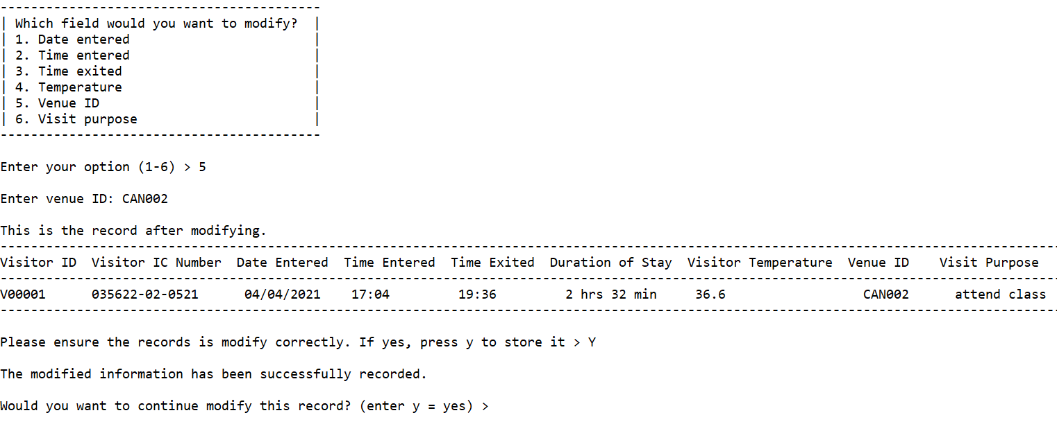

This image shows the output if user chooses 5 to modify venue id.

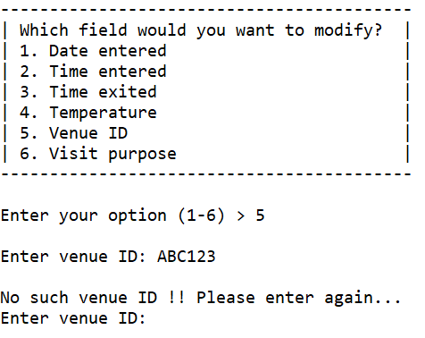

This image shows the validation of venue id. If the venue id is not found in venue’s information records, it means that the venue id is invalid and the user will need to enter a valid venue id again.

Modify Visit Purpose

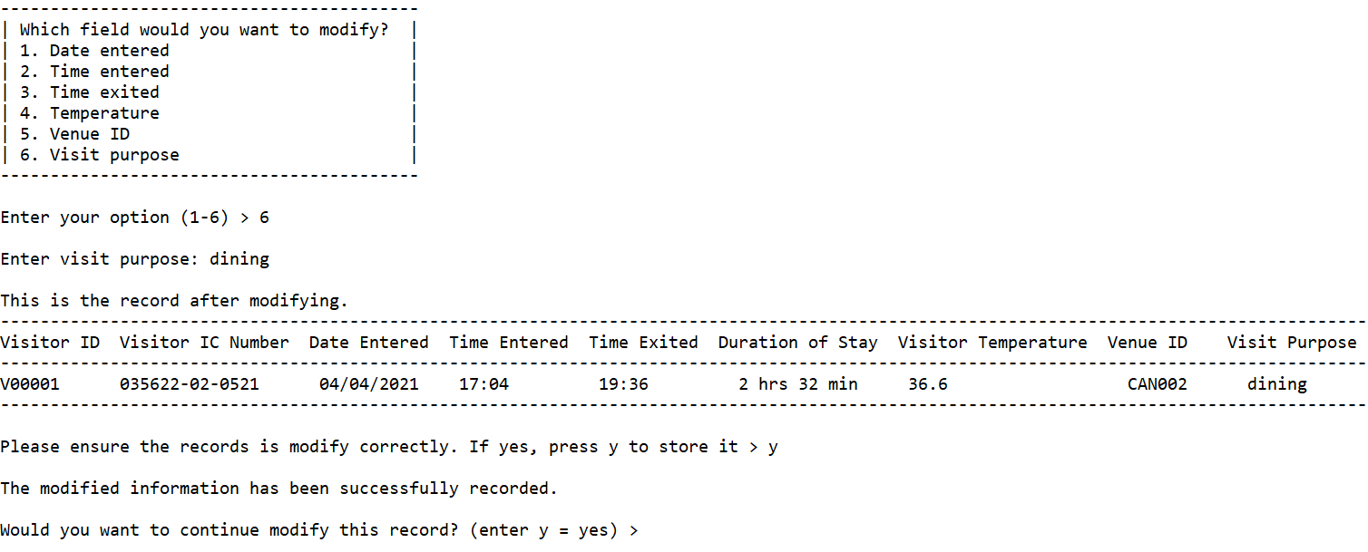

This image shows the output if user chooses 6 to modify visit purpose.

**Delete Visits and Exits Records**

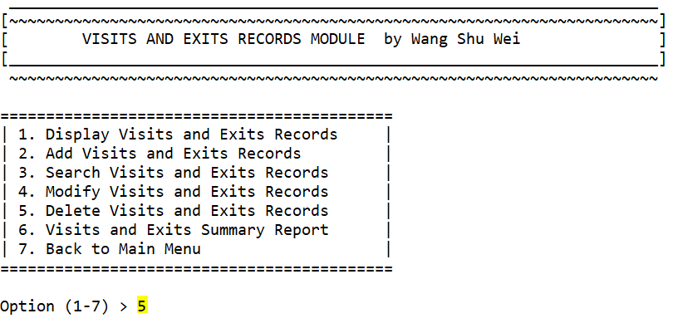

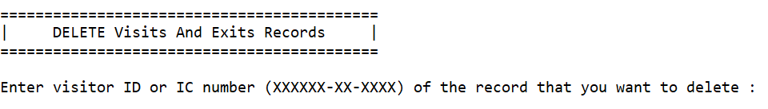

These two images show that if user enters 5 in the visits and exits menu, it will display DELETE function.

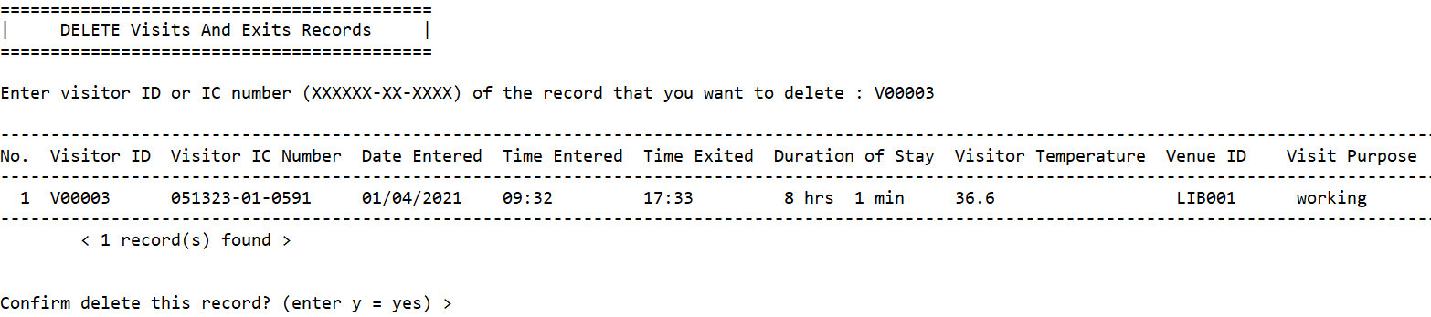

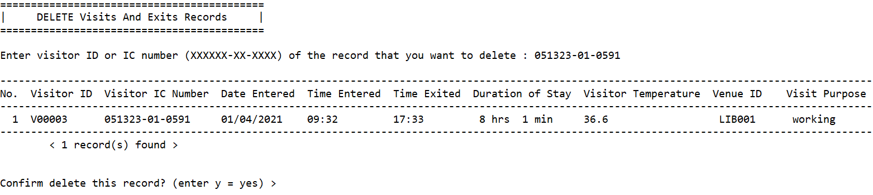

These two images show that the user can either search by visitor id or ic number for deleting the certain record.

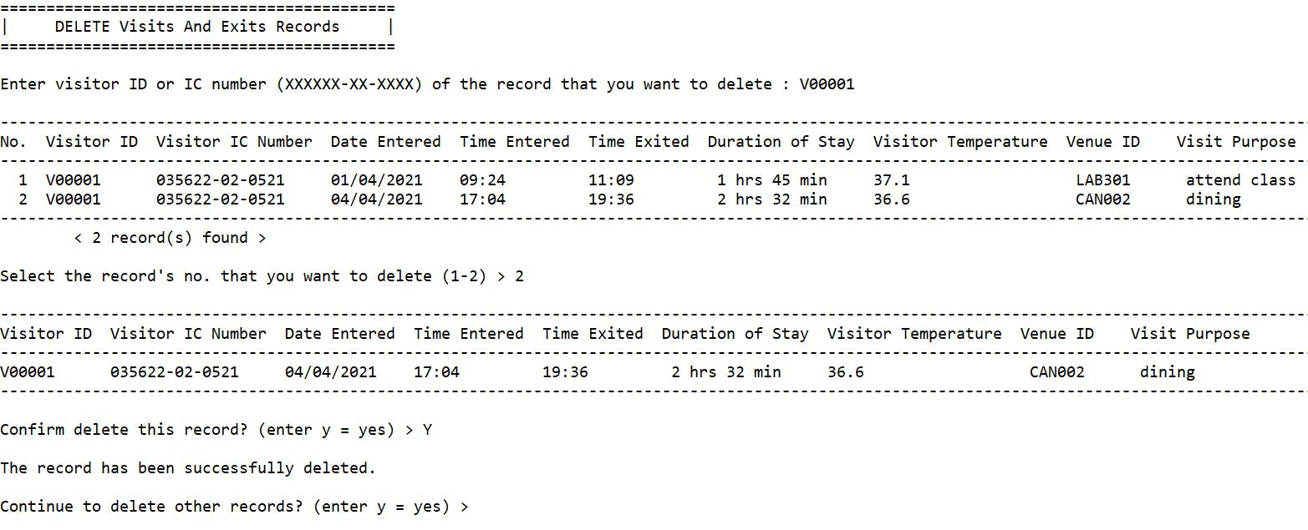

This image shows that if there are more than 1 records found by the visitor id, the user can select one of them for deleting by entering its sequence number. Lastly, it will allow the user to continue delete records by entering ‘y’.

**Visits and Exits Report**

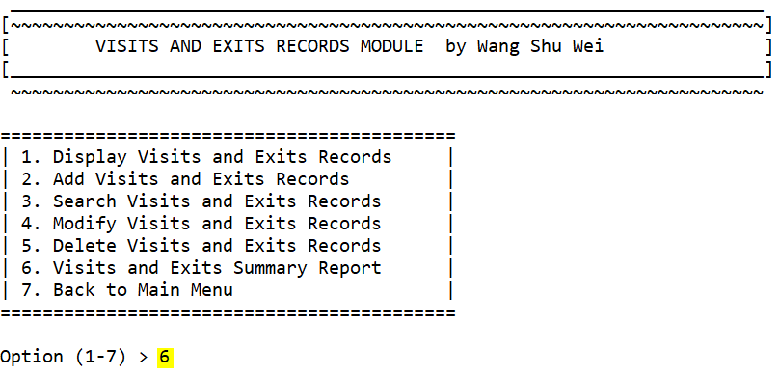

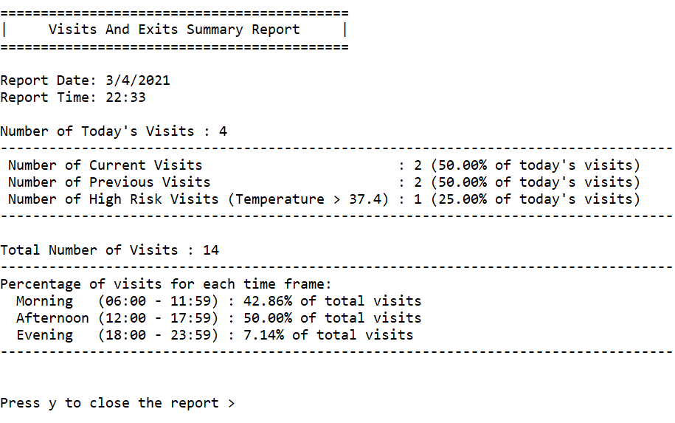

This image shows the output of Visits and Exits Report.

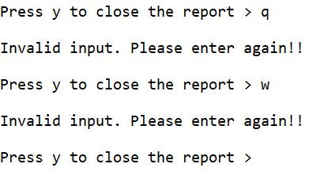

This image shows the validation of user input to close the report.

**4.5 Sanitization Records Module by Thong So Xue**

**4.5.1 Brief Description**

**Main Function of this Module**

The function of this module is to record, store and maintain sanitization records. A sanitization record will be made whenever a sanitization company is hired to perform sanitization on a venue within the school or college. There are six main functions in this module, which includes adding, modifying, displaying, searching, deleting and producing reports from the stored records.

1. **Sanitization Records Module’s Main Menu Function (sanitizationRecordsModule)**

This function is the menu function that connects all the 6 main functions together in one place. The user is able to choose which function to perform by entering the numbers 1 to 7, and the system will call the corresponding functions, namely add, modify, delete, display, search and report records. Entering 7 will allow the user to exit from this module back to the main menu. Upon entering any of the options between 1 to 7, the screen will be cleared.

1. **Add Records Function (addRec)**

* After entering 1 in the sanitization module’s main menu, this function will be called.
* Upon the launch of this function, the program will auto calculate the newest Sanitization Record ID for the new record, and start the add record session by prompting the user to enter the information for the new sanitization record.
* The information required to be entered are the Date, Start time, End time, Venue ID, Sanitization Company’s Name, Sanitization Company’s Contact Person, Sanitization Company’s Contact Number, Sanitization Type and the Sanitization Price.
* All the inputs above will be validated thoroughly in order to avoid data inaccuracies. When entering the venue ID and type of sanitization for the record, the program will list out all the available venue IDs and types of sanitization for the user to choose from. Besides that, the user can also choose to “Auto-calculate Based on Venue Area Size” or “Manually Input a Price” when entering the value of Sanitization Price.
* After entering all the required information, the program will display a preview of the new record and allow the user to review the information entered. If the user wishes to confirm to add this record, by entering ‘Y’, the new record will be added into the records and files. If not, by entering ‘N’, the draft of this new record will be discarded.
* Regardless of choosing ‘Y’ or ‘N’ during the add record confirmation, the program will ask the user if he or she wants to add another record. Upon agreeing by entering ‘Y’, the screen will be cleared and a new add record session will be prompted. If not, by entering ‘N’, the user will be brought back to the sanitization module’s main menu.

1. **Modify Records Function (editRec)**

* After entering 2 in the sanitization module’s main menu, this function will be called.
* Upon the launch of this function, the program will prompt the user to enter a Record ID to modify. If the Record ID entered by the user is found, the program will start a modifying record session. If not, the program will ask if the user would like to modify another record. If ‘Y’ is entered, the above step will be repeated. Else, if ‘N’ is entered, the user will be brought back to the sanitization menu function.
* During the modifying record session, the top of the screen will always display two records: a copy of what the current record looks like, and a preview of what the modified record will look like, thus allowing the user to compare the modifications side by side. A menu listing all modifiable fields will be displayed below them and the program will prompt the user to choose a field to modify.
* The user can input 1 to 9 to modify the following fields, namely Date, Start time, End time, Venue ID, Sanitization Company Name, Sanitization Company Contact Person, Sanitization Company Contact Number, Sanitization Type and Sanitization price.
* Besides that, the user can also input 10, which is the “Confirm Modification” option. If this option is chosen, the program will ask for confirmation from the user to modify this record. If ‘Y’ is entered, the modifications made will be updated to the records and files. If ‘N’ is entered, the modifications will be discarded and the original record will remain unchanged.
* After all that, the program will ask if the user would like to modify another record. If ‘Y’ is entered, the above processes will be repeated, starting from the user being prompted to enter another Record ID to modify. If ‘N’ is entered, the user will be brought back to the sanitization module’s main menu.

1. **Delete Records Function (deleteRec)**

* After entering 3 in the sanitization module’s main menu, this function will be called.
* Upon the launch of this function, the program will allow the user to enter a Record ID to delete.
* If the Record ID entered by the user is found, the program will show a copy of all the record details, and ask if the user wants to delete this record or not. If ‘Y’ is entered, the selected record will be deleted from the records and files. If not, If ‘N’ is entered, no changes will be made on the records and files.
* The program will then ask if the user would like to delete another record. If ‘Y’ is entered, the above processes will be repeated, starting from prompting the user to enter a Record ID to delete. If ‘N’ is entered, the user will be brought back to the sanitization module’s main menu.

1. **Search Records Function (searchRec)**

* After entering 4 in the sanitization module’s main menu, this function will be called.
* Upon the launch of this function, the program will display a list of all record details that the user can search from, which from 1 to 10, are Record ID, Date, Start time, End time, Venue ID, Sanitization Company’s Name, Sanitization Company’s Contact Person, Sanitization Company’s Contact Number, Sanitization Type and Sanitization Price. The program will then prompt the user to enter an option from 1 to 10 to search the records, or 0 to quit this function and return to the sanitization module’s main menu.
* If the user has chosen any option between 1 to 10, the program will then ask for the respective inputs from the user to be used as the searching criteria. Besides, when searching by sanitization date, start time, end time and sanitization price, the user is able to choose from searching by a single value or by a range of values.
* The program will then display the records that match the values entered by the user in the selected fields in a clean table format.
* After that, pressing any keys will clear the search results and the above processes will be repeated, starting from the program displaying a list of all record details that the user can search from.

1. **Display Records Function (displayRec)**

* After entering 5 in the sanitization module’s main menu, this function will be called.
* Upon the launch of this function, the program will automatically display all the current records and their details in a clean table format.
* There are a total of 10 record details, namely Record ID, Date, Start time, End time, Venue ID, Sanitization Company’s Name, Sanitization Company’s Contact Person, Sanitization Company’s Contact Number, Sanitization Type and Sanitization Price.
* Pressing any key in this function will bring the user back to the sanitization module’s main menu.

1. **Report Records Function (reportSanRec)**

* After entering 6 in the sanitization module’s main menu, this function will be called.
* Upon the launch of this function, the program will display a menu showing the available reports that can be printed. Entering 1 to 3 will print the respective reports, and entering 4 will quit this function and return back to the sanitization module’s main menu.
* If the user chooses 1, the program will print the Monetary Details on Hiring Sanitization Companies report, which consists of 4 fields, namely Sanitization Company’s Name, Total Money Spent on Hiring, Times Hired and Average Amount per Hire.
* If the user chooses 2, the program will print the Sanitization Details of Each Venue report, which consists of 3 columns, namely Venue ID, Number of Times of Sanitization, and the Money Spent on Sanitizing it.
* If the user chooses 3, the program will print the Venues that Require Sanitizations report, which consists of 3 columns, namely Venue ID, Last Sanitization Date and the Days since Last Sanitization.
* After viewing any reports, pressing any key will clear the search results, and the above processes will be repeated, starting from the program displaying a menu showing the available reports that can be printed.

**4.5.2 Outputs and File Contents**

1. **Sanitization Records Module’s Main Menu Screen**

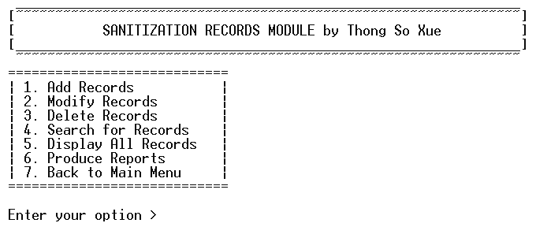

This is the main menu screen of the sanitization records module. The user can choose an option from 1 to 7 to perform the corresponding actions. Entering ‘7’ will bring the user back to the Main Menu.

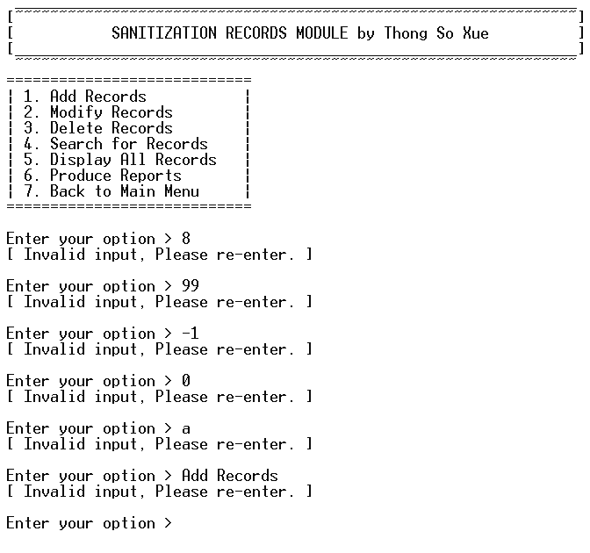

If the entered input is not a value between 1 to 7, it will be considered as an invalid input and the user will be prompted to re-enter the input.

1. **Add Sanitization Records Screen**

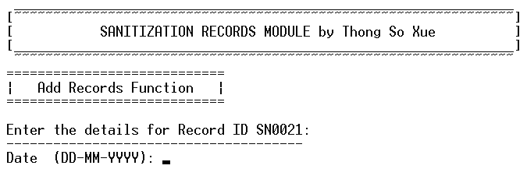

After entering 1 in the menu module, the screen will be cleared and the system will start prompting as the above image has shown. The user will need to enter the sanitization date for the record.

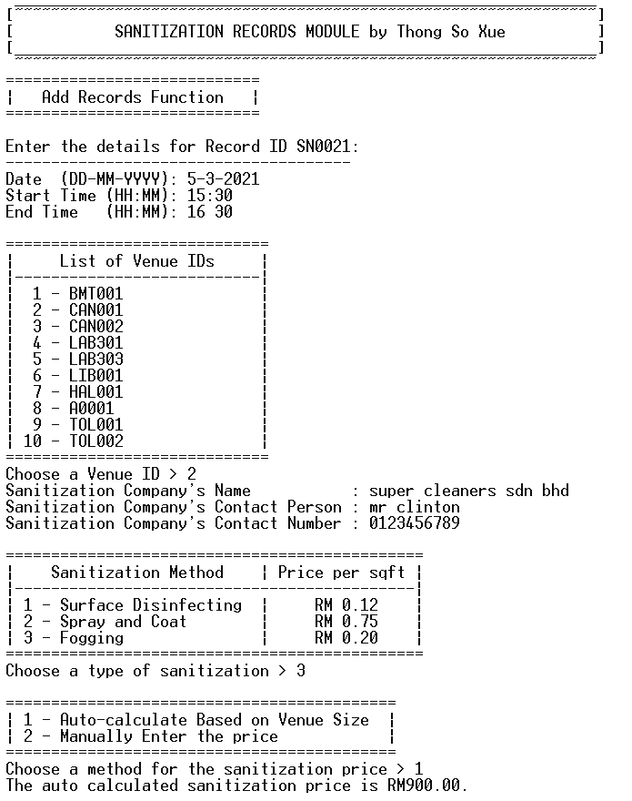

The above image shows what a complete process of add record session should look like.

**2.1 Input Sanitization Date**







The above 3 images show some examples of valid inputs that are accepted by the system.

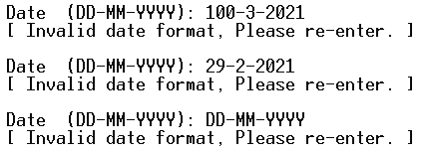

The above image shows some examples of invalid date inputs that are not accepted by the system.

**2.2 Input Start Time**







The above images show some examples of valid inputs that are accepted by the system.

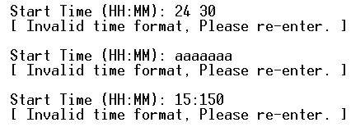

The above image shows some examples of invalid time inputs that are not accepted by the system.

**2.3 Input End Time**







The above images show some examples of valid inputs that are accepted by the system

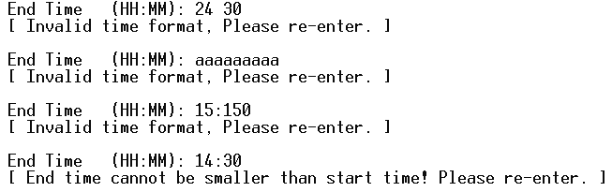

The above image shows some examples of invalid time inputs that are not accepted by the system.

**2.4 Input Venue ID**

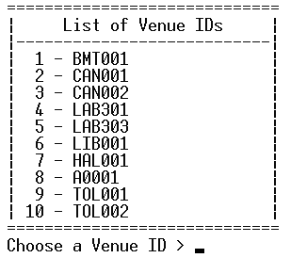

The above image shows what will be displayed during the input venue ID phase.

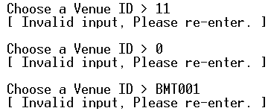

The above image shows some examples of invalid venue ID inputs that are not accepted by the system.

**2.5 Input Sanitization Company’s Name**





Both of the above images show examples of inputting Sanitization Company’s Name. Both of the above images will yield the same result, i.e. “Super Cleaners Sdn Bhd” due to the system automatically capitalizing the first letter of every word.

**2.6 Input Sanitization Company’s Contact Person**





Both of the above images show examples of inputting Sanitization Company’s Contact Person. Both of the above images will yield the same result, i.e. “Mr Clinton” due to the system automatically capitalizing the first letter of every word.

**2.7 Input Sanitization Company’s Contact Number**



The above image is an example of inputting Sanitization Company’s Contact Number.

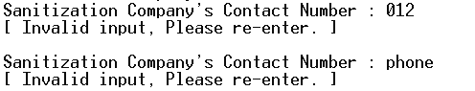

The above image shows some examples of invalid contact number inputs that are not accepted by the system

**2.8 Input Sanitization Type**

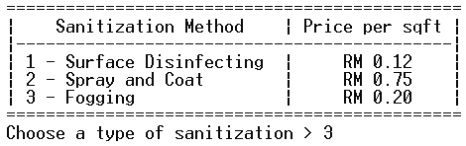

The above image shows an example of inputting the type of sanitization. Only 1, 2, 3 are valid inputs.

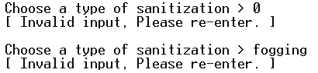

The above image shows some examples of invalid sanitization type inputs that are not accepted by the system

**2.9 Input Sanitization Price**

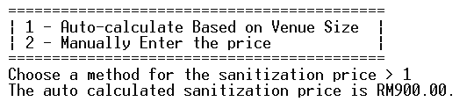

The above image shows an example of choosing ‘1’ to input the sanitization price. No further input is required from the user in this phase.

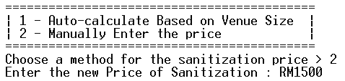

The above image shows an example of choosing ‘2’ to input the sanitization price. The user is required to input the price of sanitization manually.

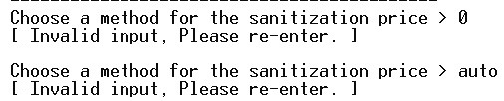

The above image shows some examples of invalid inputs for the method of sanitization price that are not accepted by the system.

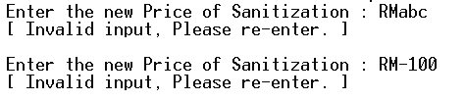

The above image shows some examples of invalid inputs for the manual price of sanitization that are not accepted by the system

**2.10 Preview of the record**

As shown in the above image, after inputting the values, the system will show a preview of the new record. Note that both the first letter of every word in the Sanitization Company’s Name and Contact Person' will be capitalized.

**2.11 Confirm to Add record**



The above image is a representation of the user entering ‘Y’ to confirm to add this record into the system. Note that both inputting ‘Y’ and ‘y’ will yield the same result.



The above image is a representation of the user entering ‘N’ to not add this record into the system. Note that inputting ‘N’ or ‘n’ will yield the same result.

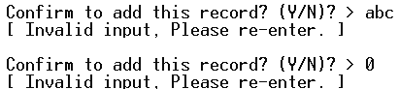

The above image shows some examples of invalid inputs during the confirmation process that are not accepted by the system.

**2.12 Add another record**



The above image is a representation of the system prompting the user to “Add another record?” or not. Inputting ‘Y’ or ‘y’ will start another add record session.

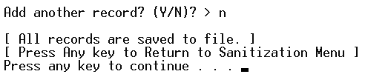

The above image is a representation of the user entering ‘n’ or ‘N’ to not add another record. The system will save all the data to file and return to the sanitization menu screen.

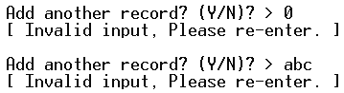

The above image shows some examples of invalid inputs during the add another record phase that are not accepted by the system.

1. **Modify Sanitization Records Screen**

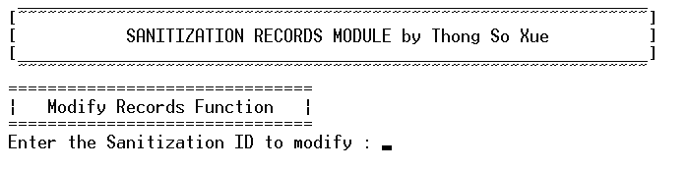

This is what the user will first see when the user enters ‘2’ in the Sanitization record module’s main menu.

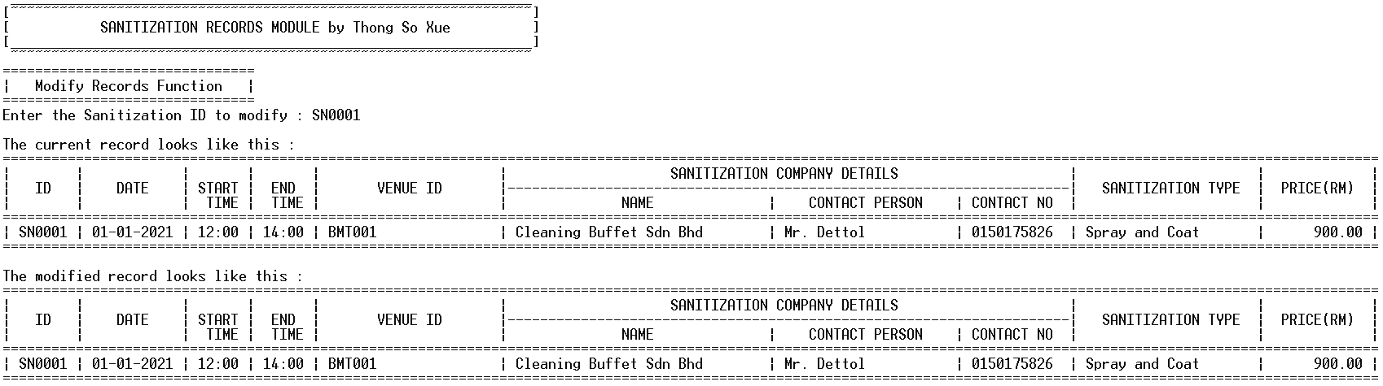

After entering a valid Sanitization ID, the system will display two record previews, the one above displays what the original record looks like, while the one below displays what the newly modified record looks like.

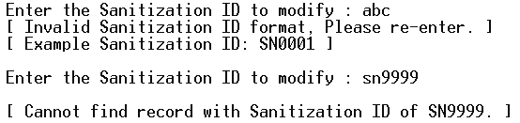

The above image shows some examples of invalid Sanitization ID inputs that are not accepted by the system.

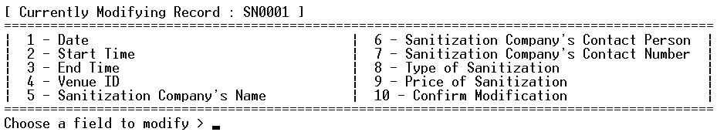

The above image is a menu that will be displayed right below both of the record previews mentioned above.

**3.1 Modify Sanitization Date**

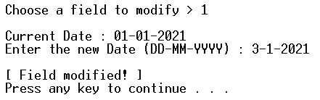

The above image shows the complete process of modifying the sanitization date.

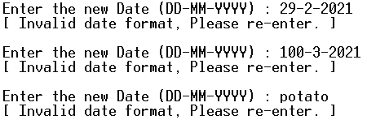

The above image shows some examples of invalid date input.

**3.2 Modify Start Time**

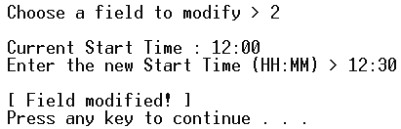

The above image shows the complete process of modifying the start time.

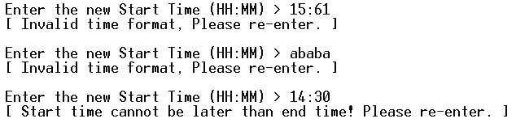

The above image shows some examples of invalid start time input. Note that start time values that are later than the end time are invalid too.

**3.3 Modify End Time**

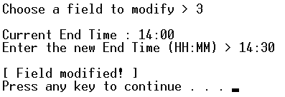

The above image shows the complete process of modifying the end time.

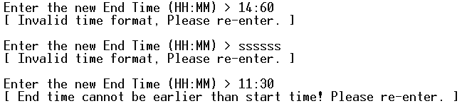

The above image shows some examples of invalid end time inputs. Note that end time values that are earlier than the start time are invalid too.

**3.4 Modify Venue ID**

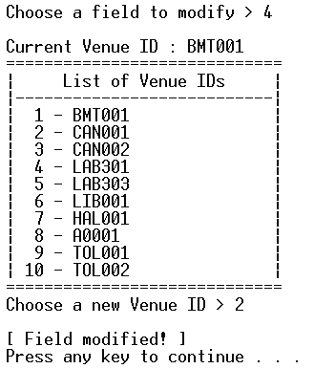

The above image shows the complete process of modifying the Venue ID.

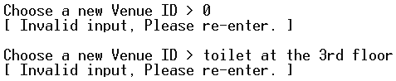

The above image shows some examples of invalid inputs. Only the numbers that are listed on the menu are valid to be accepted by the system.

**3.5 Modify Sanitization Company’s Name**

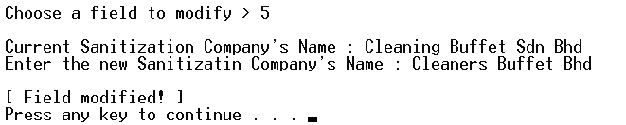

The above image shows the complete process of modifying the Sanitization Company’s Name.

**3.6 Modify Sanitization Company’s Contact Person**

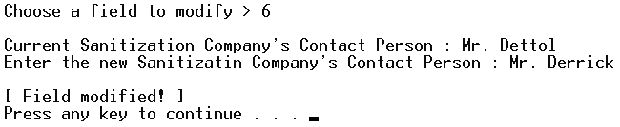

The above image shows the complete process of modifying the Sanitization Company;s Contact Person. .

**3.7 Modify Sanitization Company’s Contact Number**

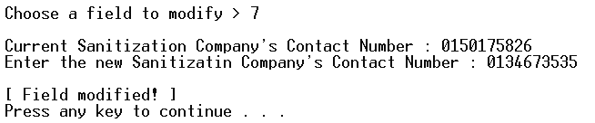

The above image shows the complete process of modifying the Sanitization Company’s Contact Number.

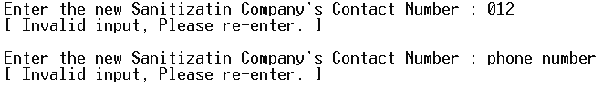

The above image shows some examples of invalid contact number inputs.

**3.8 Modify Sanitization Type**

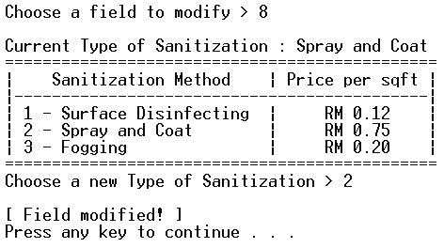

The above image shows the complete process of modifying the sanitization type.

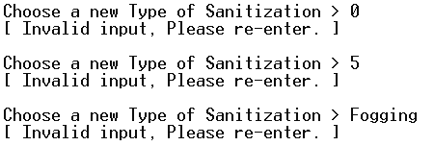

The above image shows some examples of invalid inputs. Only the numbers 1,2,3 are valid inputs.

**3.9 Modify Sanitization Price**

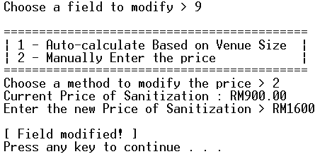

The above image shows the complete process of modifying the sanitization price.

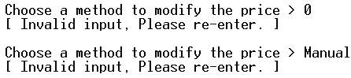

The above image shows some examples of invalid inputs for the method to modify the price. Only the numbers 1 and 2 are valid inputs.

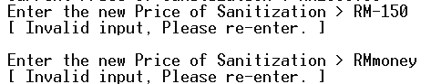

The above image shows some examples of invalid inputs for the manual sanitization price. Only positive numbers are accepted.

**3.10 Confirm Modification**

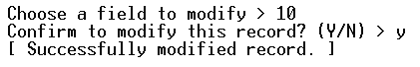

The above image shows the process of entering ‘y’ or ‘Y’ in the confirm modification phase.

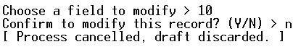

The above image shows the process of entering ‘n’ or ‘N’ in the confirm modification phase.

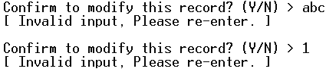

The above image shows some examples of invalid inputs. Only Y and N are valid inputs.

**3.11 Modify Another Record**



The above image is a representation of the system prompting the user to “Modify another record?” or not. Entering Y will start another modify record session.

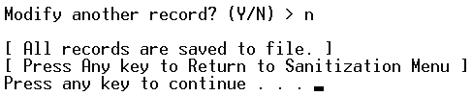

The above image is a representation of the user entering ‘n’ or ‘N’ to not modify another record. The user will be brought back to the sanitization menu screen after this.

1. **Delete Sanitization Records Screen**

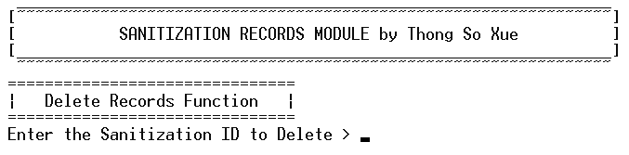

This is what the user will first see when the user enters ‘3’ in the Sanitization record module’s main menu.

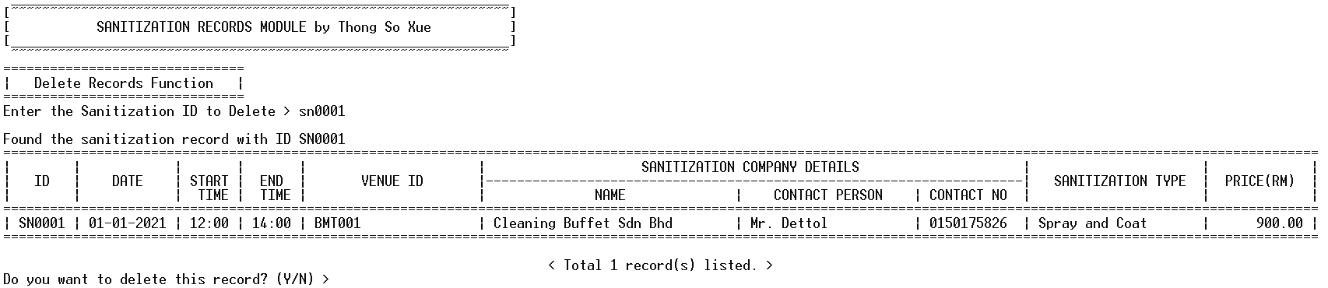

The above image is a representation of the user entering a valid Sanitization ID. The preview of the found ID’s record will be displayed and the system will ask again if the user really wants to delete this record.

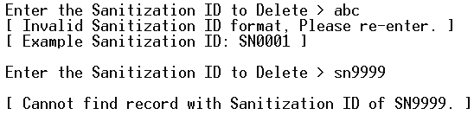

The above image is a representation of the user entering an invalid Sanitization ID.



The above image is a representation of the user entering ‘Y’ or ‘y’ to confirm to delete the found record.



The above image is a representation of the user entering ‘N’ or ‘n’ to not delete the found record.

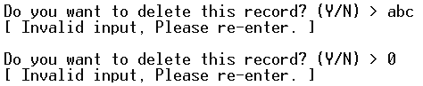

The above image shows some examples of invalid inputs for the confirmation to delete record.



The above image is a representation of the system prompting the user to “Delete another record?” or not. Entering ‘Y’ or ‘y’ here will start another delete record session, starting from prompting the user to enter a Sanitization ID to delete.

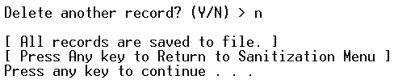

The above image is a representation of the user entering ‘N’ or ‘n’ to not delete another record. The user will be brought back to the Sanitization Menu Screen.

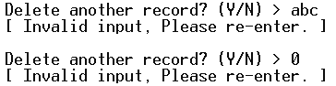

The above image shows some examples of invalid inputs for the prompt to delete another record phase.

1. **Search Sanitization Records Screen**

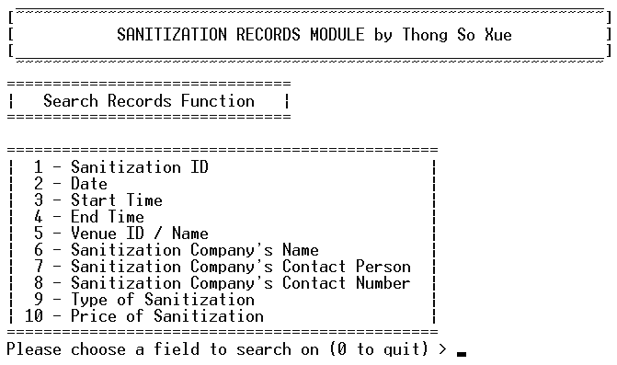

This is what the user will first see when the user enters ‘4’ in the Sanitization record module’s main menu. All the inputs and their sub-inputs will be thoroughly validated as shown in previous functions.

**5.1 Search by Sanitization ID**

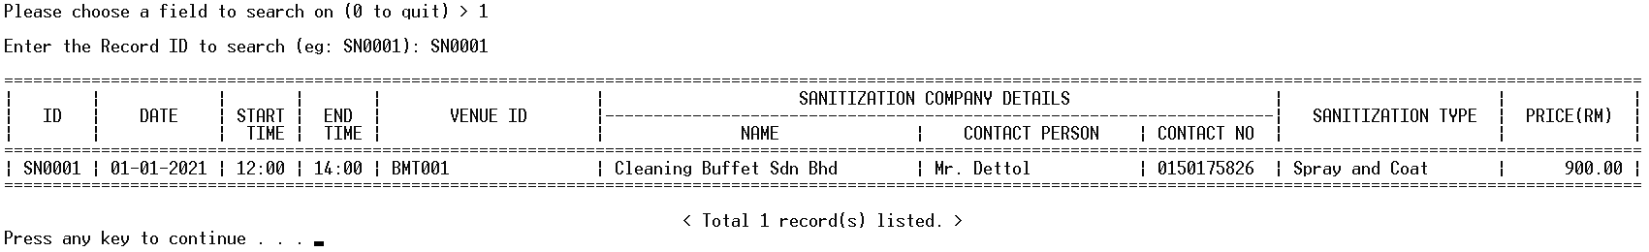

The above image shows the complete process of searching based on the Sanitization ID.

**5.2 Search by Sanitization Date**

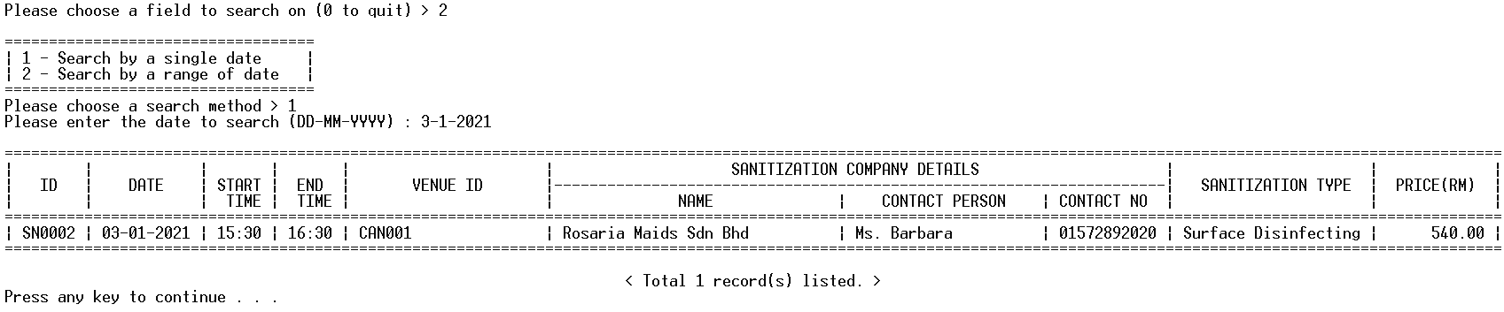

The above image shows the complete process of searching based on a single Sanitization Date.

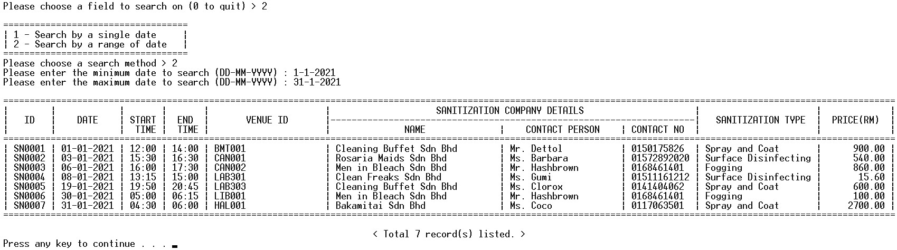

The above image shows the complete process of searching based on a range of Sanitization Dates.

**5.3 Search by Start Time**

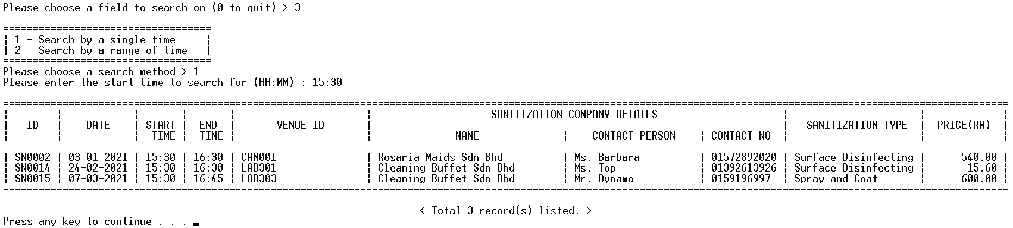

The above image shows the complete process of searching based on a single start time.

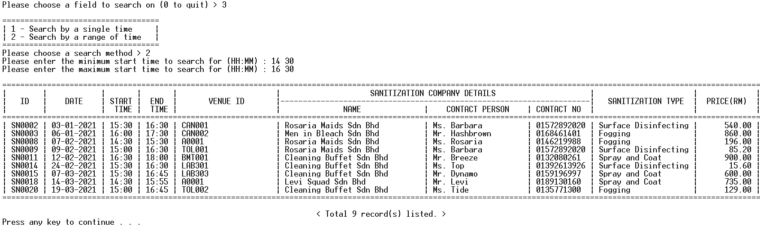

The above image shows the complete process of searching based on a range of start times. .

**5.4 Search by End Time**

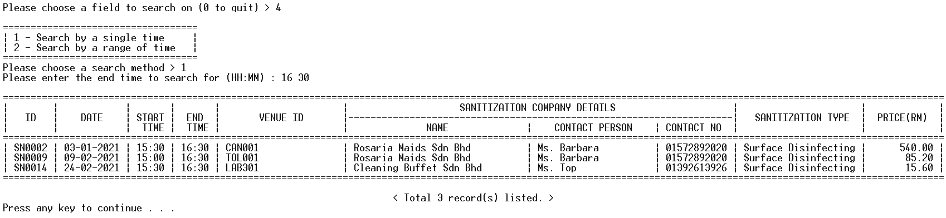

The above image shows the complete process of searching based on a single end time.

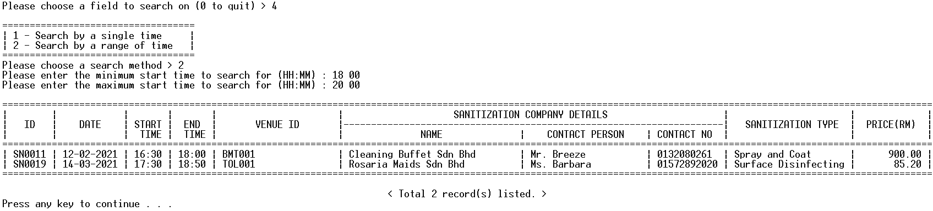

The above image shows the complete process of searching based on a range of end times.

**5.5 Search by Venue ID**

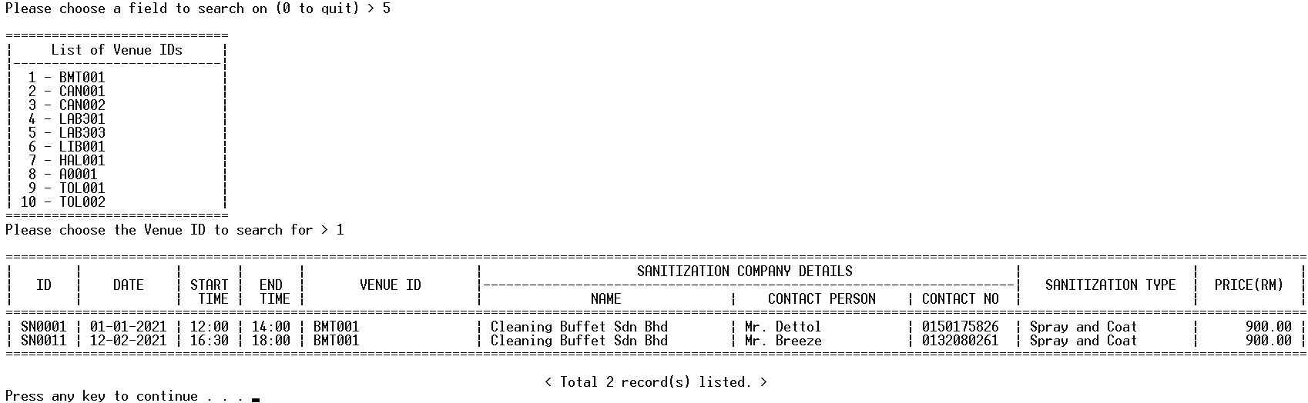

The above image shows the complete process of searching based on the Venue ID.

**5.6 Search by Sanitization Company’s Name**

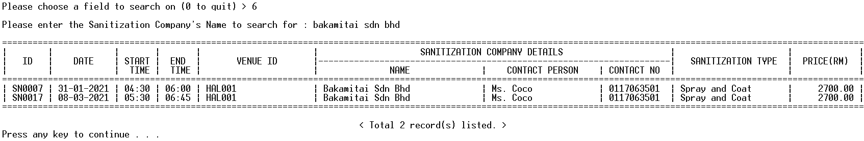

The above image shows the complete process of searching based on the Sanitization Company’s Name.

**5.7 Search by Sanitization Company’s Contact Person**

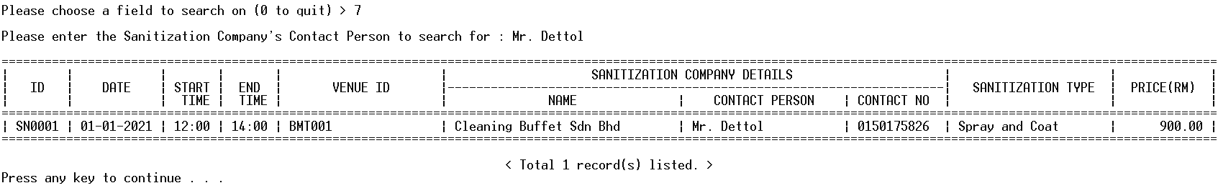

The above image shows the complete process of searching based on the Sanitization Company’s Contact Person.

**5.8 Search by Sanitization Company’s Contact Number**

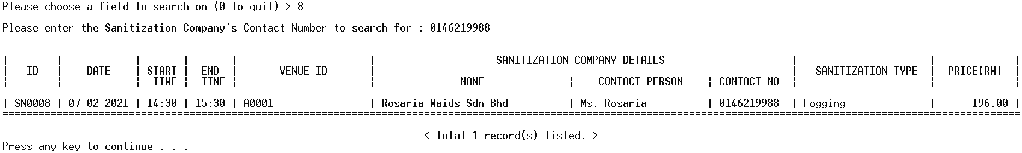

The above image shows the complete process of searching based on the Sanitization Company’s Contact Number.

**5.9 Search by Sanitization Type**

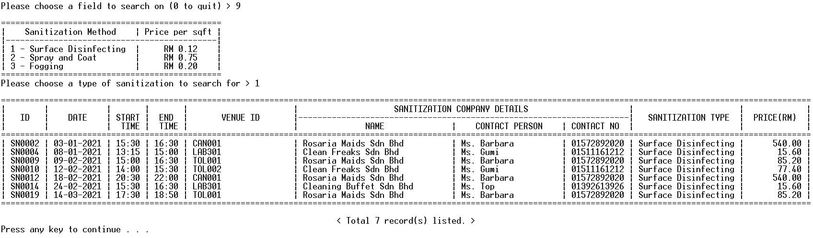

The above image shows the complete process of searching based on the Sanitization Type.

**5.10 Search by Sanitization Price**

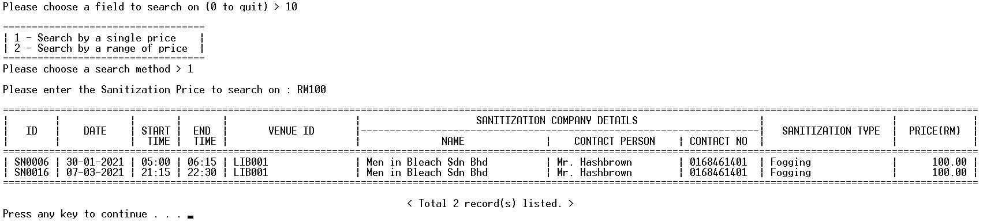

The above image shows the complete process of searching based on a single Sanitization Price.

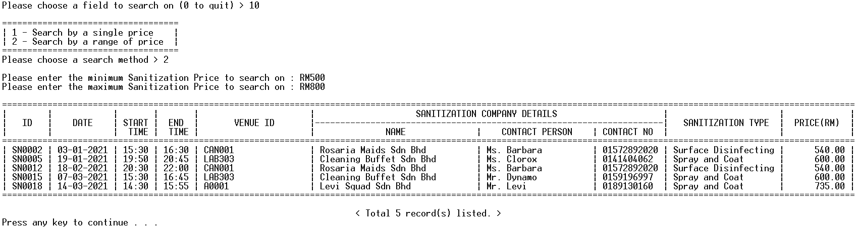

The above image shows the complete process of searching based on a range of Sanitization Prices.

**Extra: No records found**



The above image shows an example of having no records match the searching inputs entered by the user.

**5.11 Quit searching records**

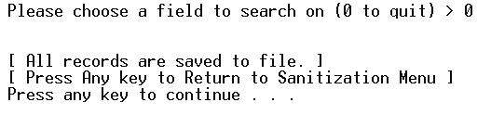

The above image is a representation of the user entering ‘0’ to quit this function. After this, the user will be brought back to the Sanitization Menu Screen.

1. **Display Sanitization Records Screen**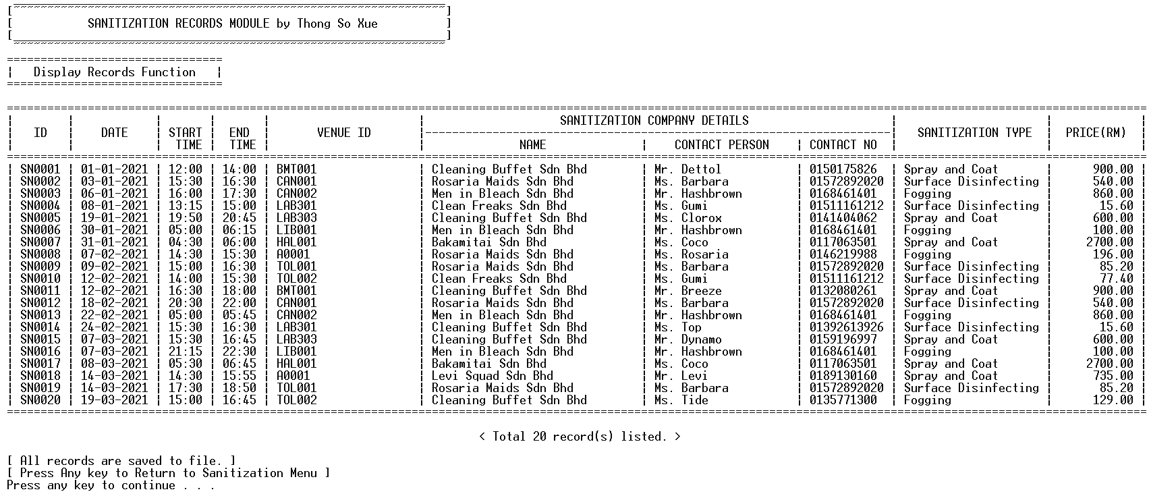

The above image is a representation of the system displaying all the sanitization records in a clean table format. Pressing any key will bring the user back to the Sanitization Menu Screen.

1. **Report Sanitization Records Screen**

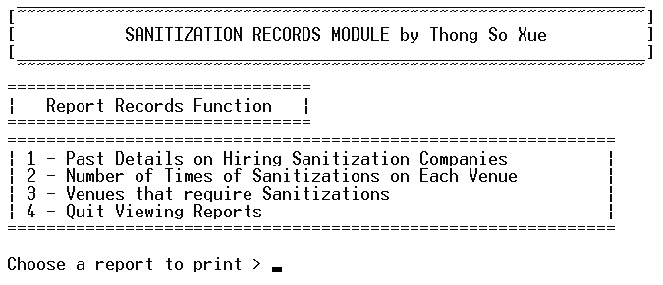

This is what the user will first see when the user enters ‘6’ in the Sanitization record module’s main menu.

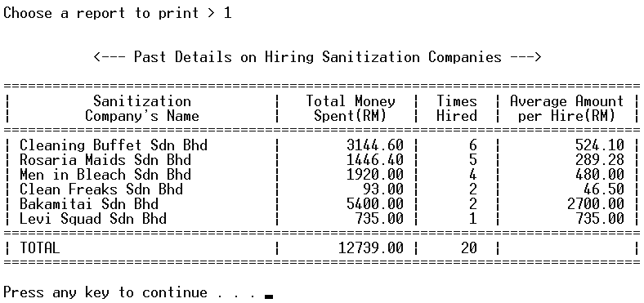

The above image is a representation of the user entering ‘1’ to print the report of “Past Details on Hiring Sanitization Companies”. Pressing any key will bring the user back to the Report Records menu.

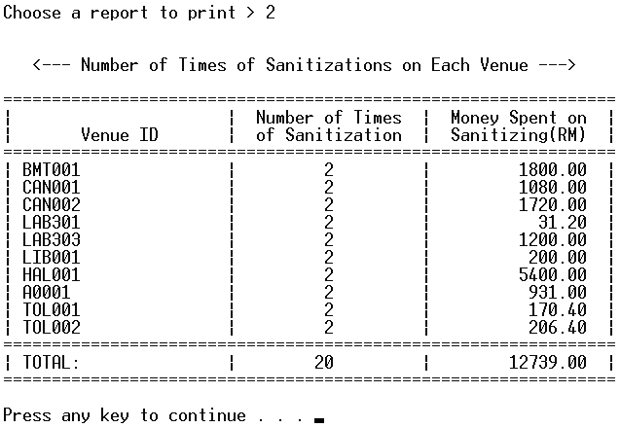

The above image is a representation of the user entering ‘2’ to print the report of “Number of Times of Sanitizations on Each Venue”. Pressing any key will bring the user back to the Report Records menu.

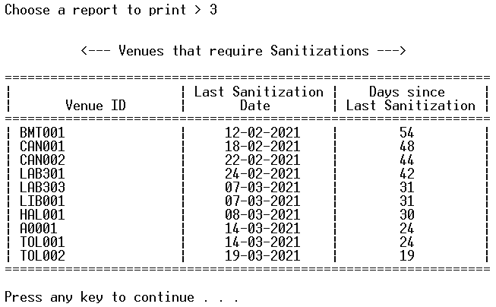

The above image is a representation of the user entering ‘3’ to print the report of “Venues that require Sanitizations”. Pressing any key will bring the user back to the Report Records menu.

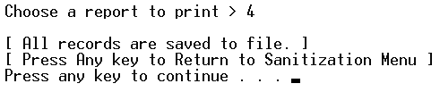

The above image is a representation of the user entering ‘4’ to quit printing reports. The user will be brought back to the Sanitization Menu Screen.

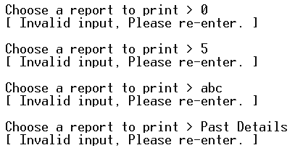

The above image shows some examples of invalid inputs for the Report Records menu options. Only the numbers 1. 2. 3 and 4 are valid inputs.